TEAM PROJECT REPORT

**Modeling of Signalized Intersection Design and Impacts**

Submitted To

The RET Site

For

“Challenge-Based Learning and Engineering Design Process Enhanced Research Experiences for Secondary School and 2 and 4 Year Teachers”

Sponsored By

The National Science Foundation

Grant ID No.: EEC-1710826

College of Engineering and Applied Science

University Of Cincinnati, Cincinnati, Ohio

Prepared By

**Participant # 1: Girija Nair-Hart, PhD, University of Cincinnati Clermont, Batavia, Ohio**

**Participant # 2: Lynn Brant, Mathematics, 9 – 12, Kings High School, Kings Mills, Ohio**

Approved By

_________________________________________

Dr. Heng Wei, P.E.

Intelligent Transportation Engineering Department of Civil & Architectural Engineering & Construction Management

College of Engineering and Applied Science

University of Cincinnati

Reporting Period: June 10 – July 26, 2019

**Abstract**

Through this RET research project, *Modeling of Signalized Intersection Design and Impact,* the RET participants (participants) sought to investigate viable means to increase the Level of Service (LOS) on the Martin Luther King (MLK) Corridor, specifically the intersections of Martin Luther King Drive, Jefferson Avenue, Vine Street, and Short Vine Street. Specifically, the goal was to analyze the flow of traffic at the MLK Corridor as a whole to improve the Signal-timing to increase the LOS at this intersection. Data for this study were previously collected by human traffic counters at this intersection. Based on the data collected after running the first round of simulation, the intersections are assigned appropriate levels of service based on the HCM rating stipulations of A, B, C, D, E, F. Considering vehicle delay at MLK, the major roadway, as the dependent variable various changes were made in cycle lengths and through further simulations, data were collected corresponding to the changes implemented. Through a *before-after* analysis the best delay minimizing option appeared to be to extend the cycle length for all three intersections: MLK-Vine/EPA, MLK-Jefferson, and MLK-Short Vine.

**Key Words**

Level of service, signalized intersection, roundabouts, traffic delay, traffic flow, simulations

**Main Body**

**1. INTRODUCTION**

**Elements of a Signalized Intersection**

In order to understand traffic behavior at signalized intersections one needs to have a basic understanding of traffic control at intersections. The definitions of technical terms used in this research paper can be found in the nomenclature. An intersection is a common space where two or more roads carrying traffic streams in different directions cross. At such a location, different traffic streams compete with each other for the use of the common space in the intersection and flow conflicts will be generated along with a high safety risk. If left alone the flow in these intersections will be chaotic compromising the safety and efficiency of traffic flow. In modern times, signalization is one of the strategies used in controlling the traffic flow to improve its safety and efficiency. At signalized intersections conflicting traffic streams are denied and scheduled in different time-line phases to enter the intersection, the common space at the same time. Thus, traffic intersections reduce conflicts between road users and improve efficiency and safety. Traffic intersections are time shared through various strategies such as pre-timed, partially (semi) actuated, and fully actuated signalizations. Interruptions that occur at these intersections obstruct the smooth flow of traffic.

To be effective, a traffic control device should meet five basic requirements: fulfill a need, command attention, convey a clear simple meaning, command respect from road users, and provide adequate response time (Manual on Uniform Traffic Control Devices). The factors that the participants were focused on while conducting traffic analysis were level of service, identifying the delay, loss of travel time, travel time, and speed. Delay predicts the average stopped time in seconds per vehicle calculated separately for each lane group.

**The Level of Service (LOS)**

The LOS is a measure used to evaluate the operational performance of roadway facilities recommended by the Highway Capacity Manual (HCM 2010). Minimum traffic delay is considered most conducive to optimal LOS. Traffic delay is caused by factors such as signal control, the geometrics of the intersection, traffic flow, and obstructive incidences caused by approaching vehicles. The LOS for signalized intersections is measured by the difference between the base travel time calculated without the presence of obstructions to the flow of traffic and the actual travel time experienced in real settings. Based on the average control delay in seconds per vehicle, the LOS will be assigned a rating of LOS A, LOS B, LOS C, LOS D, or LOS E. Table 1 provides the level of service criteria for signalized intersections. The LOS is a step function of the average control delay measured in seconds per vehicle. The results ought to be interpreted bearing in mind how very small changes in the number of delay seconds might affect the percentages that correspond to the cutoff point between various levels of services ranging from LOS A through LOS F.

**Table 1. Level of Service Criteria for Signalized Intersections**

|  |  |  |
| --- | --- | --- |
| **Level of**  **Service**  **LOS** | **Average Control Delay** | **General Description** |
| A | ≤ 10 | Free Flow |
| B | > 10 - 20 | Stable Flow (slight delays) |
| C | > 20 - 35 | Stable Flow (acceptable delays) |
| D | > 35 - 55 | Approaching unstable flow (tolerable delay, occasionally wait through more than one signal cycle proceeding |
| E | > 55 - 80 | Unstable flow (intolerable delay) |
| F | > 80 | Forced flow (congested and queues fail to clear) |

**2. LITERATURE REVIEW**

Many researchers have investigated the LOS at signalized intersections using various methods. The LOS experienced by vehicles as well as pedestrians are summarized in the in this section. In these studies, the analysis of LOS was informed by various factors such as non-stationary traffic flow, mixed traffic conditions, delay, and que length. Simulations and Webster’s study model were used to carry out the research in these cases. In Webster’s (British) model, optimum cycle length is estimated based on volume to saturation ratio.

Optimum cycle length = $\frac{1.5 L+5}{1- \sum_{i=1}^{n}{y_{i}}}$

where L is the total lost time, y is the volume to saturation ratio, n is the number of signal phases

Delay at signalized intersections considering non-stationary traffic flow has been investigated to assess LOS by means of simulation (Leyn, U., & Vortisch, P., 2017).  In this study, the analysis of measurement data showed that peak hour traffic volume can be allocated in different forms. The researchers derived a set of abstract flow patterns that modeled peak hour simplified flow profiles split into 15-min-intervals. Microscopic traffic flow simulations were performed for various signal control groups and volume-to-capacity ratios to determine the delay caused by the different traffic flow patterns. They noted that in most cases delay is higher for non-stationary flow than for stationary flow. Finally, a correction factor was developed for delay computation method based on HCM of Germany to better reflect the volume distribution within the design hour.

In another research (Ye, X., Chen, J., Jiang, G., & Yan, X., 2015), that identified the factors affecting the pedestrian level of service (LOS) at signalized intersection crosswalks was studied. The goal of this research was to develop a suitable method for estimating pedestrian LOS in Beijing, China. They used Webster’s delay model under mixed traffic conditions. The data was collected by video and a questionnaire survey. The participants consisted of 1,257 pedestrians and their real-time sense of comfort and safety when crossing five selected intersections and the operational characteristics of the intersections were considered for this study. The significant factors affecting LOS were determined by Pearson correlation analysis and linear regression techniques considering perceived LOS as the dependent variable. The results showed that the cumulative logistic model fit the survey data better than the linear regression model and produces LOS A for the crosswalks.

In a research study, LOS at four selected major intersections in Hyderabad city, India and was evaluated for existing traffic signal facilities (Ramesh, A., & Molugaram, K., 2018). In this study, parameters such as delay and queue length and Level of Service (LOS) were considered for evaluation. Simulation results showed that all intersections caused longer delay and larger queue length on major traffic approaches. Delays and average queue lengths at these intersections were improved through channelization that provided alternative route for U-turn and left turn traffic movements. This has also resulted in achieving improved of level of services at the all signalized intersections.

The current research focused on investigating a cost-effective intervention to the MLK Corridor that operates ineffectively during peak hours of traffic. First alternative is about improving the signal timing scenario in order to reduce the average vehicle delay mainly on the MLK corridor. Another alternative would be a traffic bridge at the intersection of MLK, Jefferson, and Vine intersection. However, the city of Cincinnati lacks funds to consider such an alternative. One potential alternative could be the installation of a roundabout to channel the right turn, left turn, and through traffic at the Jefferson road, vine street, and MLK intersection. As building a roundabout at the MLK-Jefferson-Vine intersection might be a cost-effective alternative, the RET participants created a roundabout at this intersection using the Vissim software. Then, we collected data by running a new simulation to further analyze results. The next paragraph will summarize the advantages of a roundabout.

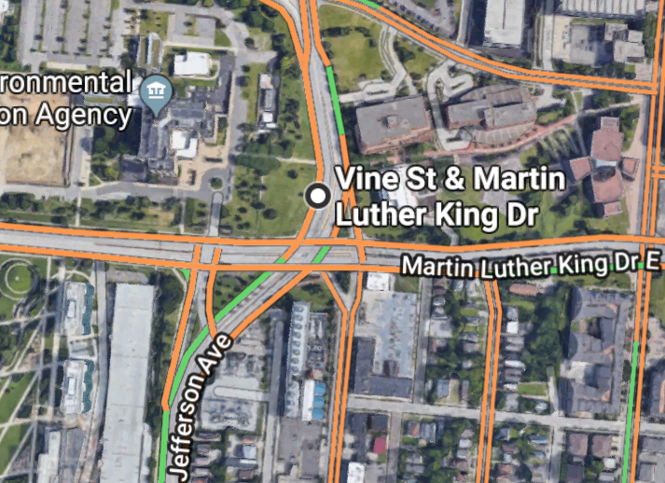

**Figure 1. Locations of the Studied Intersections**

**Roundabouts**

The capacity of a roundabout is directly influenced by traffic flow; mainly three flows of interest. They are the entering flow, the circulating flow, and the exiting flow. Roundabouts can have single or multiple lanes. The level of service criteria for roundabouts are different from that of signalized intersections. Installation of roundabouts are less costly and it can produce a smoother traffic flow. Due to increased reaction time and low speed levels the severity of vehicle crashes is low. There are no left-turn conflicts, in addition to having fewer overall conflict points compared to intersections. The vehicle delay is also lower and adjacent signals could operate with more efficient cycle lengths. Roundabouts also decrease air and noise pollution, and reduce fuel consumption since instead of coming to a complete stop vehicle will be advancing in slower speed even in higher traffic volume (NCHRP report 672/ L. A. Rodegerdts).

**Methodology**

The RET participants utilized simulations using the Highway Capacity Software 2000 (HCS 2000)

and Vissim 9.0 software to collect information about the LOS of signalized traffic intersections.

**HCS 2000**

The HCS is a traffic analysis software (Figure 2) that is produced by *McTrans Moving Technology*. It is used to analyze the current and projected LOS of various types of intersections such as signalized intersections, roundabouts, freeway facilities based on the procedures defined in the Highway Capacity Manual (HCM 2000) corresponding to three main conditions: geometric conditions, traffic conditions, and signalization conditions. Within the geometrics there are several parameters to consider. They are area type, number of lanes (N), average lane width (W), grade (G) of the road, existence of exclusive right and left turn lanes and parking. The parameters of traffic conditions include vehicle volume (V) in number of vehicles per hour, base saturation flowrate (So), peak-hour factor (PHF), percent heavy vehicles, HV (%), pedestrian flow rate, bus stopping factors, roadside parking, Arrival type (AT), proportion of vehicles arriving on green, and approach speed SA. The parameters of signalization conditions are cycle length (C), green time (G), yellow, red, and green times, actuated or pre-timed operation, minimum pedestrian green time in number of seconds, phase plan, and the analysis period (T).

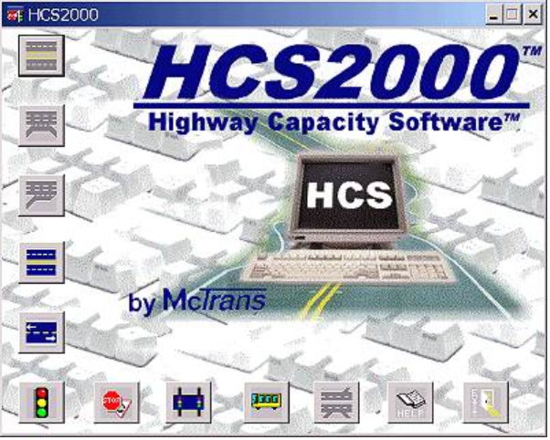

**Figure 2. Logo of HCS2010**

There are several steps involved in the data analysis process. During step 1, we entered general and site information about our intersection in regards to the analysis that we performed. In step two we selected the analysis type ("single or multiple period") and the duration (15 minutes). In step three, we used the “Quick Entry" feature to enter the geometry and volume. In step four we entered operating parameters and in step five we entered phasing design. In step six various parameters such as saturation flow rate was entered. Step seven is to show results and step 8, the final step provided the operational report. (reference - foot note 4)  
  
 The operational report provided us a breakdown of cycle length (in number of seconds) and intersection delay (per seconds per vehicle) for different arrival types based on the parameters of lane group adjustment volume (vph), lane group capacity (vph), lane group v/c ratio, critical lane group, lane group delay (sec/veh) final unmet demand (v), and approach delay (secs/veh) and the LOS for the intersections. The LOS is categorized into level E for eastbound, level C for westbound, level B for northbound, and level C for south bound. Figure 1 provides a screenshot of the result output for one of the practice problems solved.

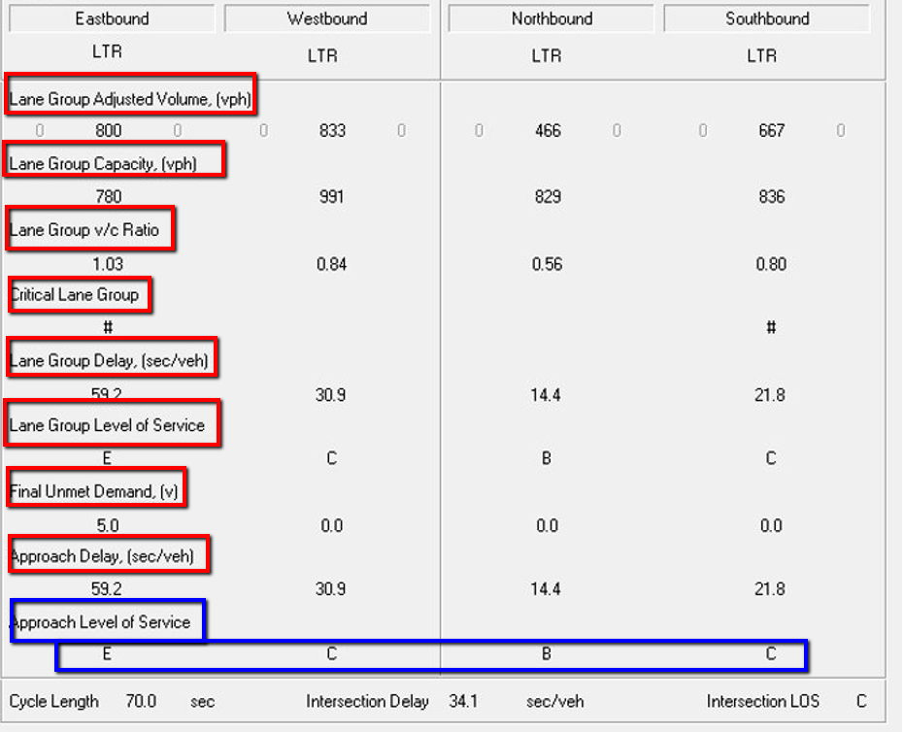

**Figure 3. Operational Report**

**Vissim 9.0**

Vissim 9.0 is a state-of-the-art simulation software (Figure 4) for realistic modelling of city and interurban traffic and pedestrian movements. (The Vissim Tutorial) The traffic flow is simulated considering lane allocation, vehicle compositions, signal control and detection of vehicles. First the RET participants set the measurements units to “all imperial” so that the units will be in check with US systems of measurement.



**Figure 4. Logo of PTV VISSIM**

First, we mapped out the existing geometrics of the Martin Luther King (MLK) Corridor, specifically the intersections of Martin Luther King Drive, Jefferson Avenue, Vine Street, and Short Vine Street. After that we re-created the roads using “links”, and “connectors”. Connectors were mainly used to connect main roads to left and right turn lanes. (show all these elements in the simulation). After the links are created, connectors are necessary to join them together. Hence a typical travel path in Vissim consists of a series of links and connectors.

Next step was to provide “vehicle inputs” that defines the traffic that should travel through the Vissim road network. They are located at the start of every link that enters the Vissim network and define the absolute vehicle volume per hour. Next, we set the “static vehicle routing decisions”. Routes define the path that a vehicle follows at road branches. We assigned routes to every vehicle arriving at a routing decision. The route choice is done according to the traffic counts collected for all the routes. The relative flow is edited in a separate list. To set the unsignalized right of way, we identified the “Conflict Areas” for merge, right, and yield. Next we used the Vissim interface for signal controllers to define signal groups to place signal heads. We set up the signal controllers and signal timing as per the data collected from the city of Cincinnati. After placing the signal heads and detectors in tact we ran the simulation. Figure 5 provides a completed model of parts of the MLK corridor featuring link, connector, conflict areas, signal heads, and detectors.

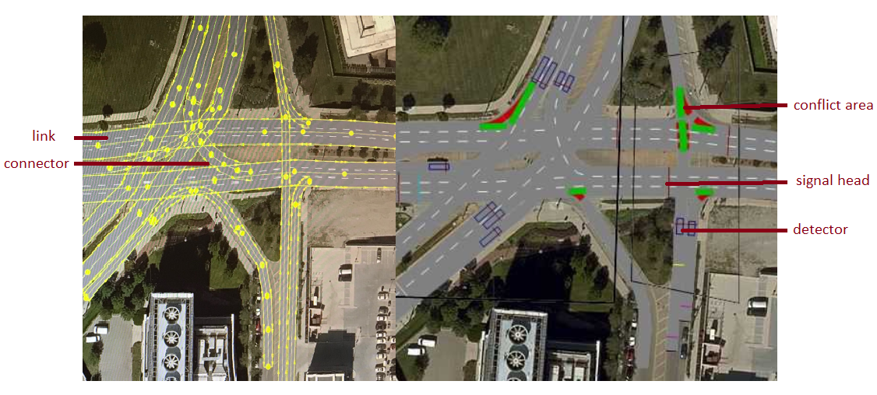

**Figure 5. Modeling MLK Corridor using Vissim 9.0**

**3. GOALS AND OBJECTIVES**

The main goal of this research was to investigate viable means to increase the Level of Service (LOS) on the Martin Luther King (MLK) Corridor, specifically the intersections of Martin Luther King Drive, Jefferson Avenue, Vine Street, and Short Vine Street.

**4. RESEARCH STUDY DETAILS**

At the beginning of the project, both RET teachers became familiar with the mathematical models and terminology related to signalized intersections. They spent five days learning the fundamental knowledge and problem-solving skills applicable to signal control design. During the second week, the RET teachers put the terminology into practical use by completing design problems for pre-timed, semi-actuated, and fully actuated intersections using the Highway Capacity Software (HCS2000). In the third week, the team received training in the advanced multi-modal PTV Vissim traffic flow simulation software. Participants learned the software by modeling the Martin Luther King-Reading intersection. Upon learning the software, participants spent the next week creating the three intersections of interest, Martin Luther King-Jefferson-Vine, in the Vissim software so that analysis of the intersection could be done as a whole rather than as three separate intersections. The Vissim analysis began with running the simulation and capturing data related to delay of vehicles and emission details.

**5. RESEARCH RESULTS**

Upon completion of the simulation that modeled the current signalized intersection design of the Martin Luther King – Jefferson – Vine corridor, RET participants received the results shown in Table 2. Of all the data generated by a VISSIM simulation, vehicle delay on the major road is the controlling factor in determining if changes are needed. Since the data entered in the simulation modeled evening peak hour traffic, the anticipation was that each of the individual intersections would be given a low LOS. Using LOS chart, RET participants ranked the five intersections with the qualitative measure. Results of this ranking are shown in Table 2.

The focus of RET participants was to improve the LOS for Martin Luther King since it is the major through road. RET participants generated five simulations making changes to the type of signalized intersection and then changing cycle length of the signals. In addition, RET participants explored the viable solutions by creating a roundabout simulation. The simulation runs are defined in Table 3. Figure 6 illustrates the alternatives of fully actuated signal control and a roundabout.

**Table 2. Current Signalized Intersection Design’s Vehicle Delay**

|  |  |  |  |  |
| --- | --- | --- | --- | --- |
| **Simulation Run** | **Time Interval** | **Delay Measurement** | **Average Vehicle Delay (10)**  **(in seconds)** | **LOS** |
| Current | 0-3600 | 1: MLK EB Thru | 43.6 | D |
| Current | 0-3600 | 2: MLK WB Thru | 37.37 | D |
| Current | 0-3600 | 3: Jefferson NB Thru | 94.6 | F |
| Current | 0-3600 | 4: Jefferson SB Thru | 32.05 | C |
| Current | 0-3600 | 5: Vine SB Left | 46.5 | D |

**Table 3. Simulation Changes**

|  |  |
| --- | --- |
| **Simulation Run** | **Changes from Current Intersection Model** |
| Pre-Timed | Deleted all of the detectors to make pre-set times for Jefferson-Vine (NB/SB) |
| Fully Actuated | Added detectors on every intersection |
| Signal Change 1-1 | Extended Cycle Length for Martin Luther King-EPA Intersection |
| Signal Change 1-2 | Kept Signal Change from 1-1  Extended Cycle Length for Martin Luther King – Jefferson Intersection |
| Signal Change 1-3 | Kept Signal Change from 1-1  Kept Signal Change from 1-2  Extended Cycle Length for Martin Luther King – Short Vine Intersection |
| Signal Change 2 | Kept green times from Signal Change 1  Deleted Detectors from Martin Luther King – Jefferson (Pre-timed intersection) |
| Signal Change 3 | Broke the long Martin Luther King Corridor into 3 separate travel time measurements in both directions and adjusted green times to try to optimize changes |
| Roundabout | EPA interchange left as current  3 Lane roundabout combining Martin Luther King-Jefferson-Vine |

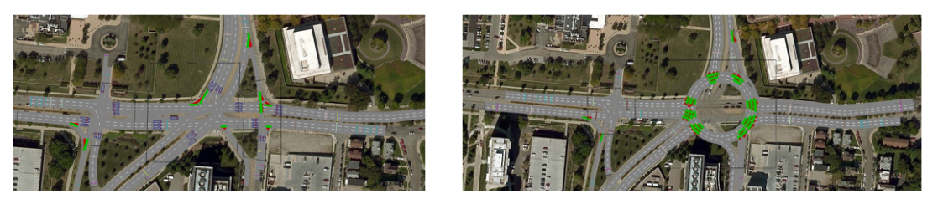

**Figure 6. Illustration of the Full-Actuated Signalization and Roundabout Alternatives**

The data gathered after each simulation change included: delay results, average speed, travel time, and emissions. The comparison graphs for this data are located in APPENDIX III. The method of research was simply a Before-After analysis which compared each new simulation with the current timing system. After thorough analysis, it was determined that the best scenario was the Simulation Run named Signal Change 1-3. In this simulation, all three cycle lengths were changed to decrease the delay time for Martin Luther King Avenue. The MLK east bound through saw a 13.26% reduction in delay time. At a quick glance, the comparison graphs might lead to misconceptions. Delay measurements are shown as the average delay in seconds per vehicle. When the differential between current and new simulation is only six seconds, it does not appear to be a large improvement; however, when you state that it is 6 seconds per 1350 vehicles that pass through the intersection, the percentage change is significant. This also lends to the realization that the LOS is really a step function so sometimes small changes allows an intersection to jump levels and a large change does not. Qualitative analysis for so many variables through the VISSIM software unveil all the complexities of facility performance.

In choosing the best scenario, there is a trade-off for setting priorities to improve the major through. By choosing simulation Signal 1-3, the MLK west bound traffic did not see an improvement in fact it increased by 1.82% over the current signalized intersection. A possible limitation is that the simulation data was from evening peak hours when more traffic is heading east to leave the University of Cincinnati and the area businesses. The environmental impact comparisons are misleading at first glance because of the scale on the graphs; the selection of Signal 1-3 does not leave a more extensive carbon footprint than the current signalized intersection. Taking all these factors into consideration, the best simulation produced during this study was Signal 1-3. All data analysis graphs are located in Appendix III. The graphs include information for a 3-lane roundabout that is a simulated possibility for the intersection but not ready for practical implementation.

**6. RESEARCH CONCLUSIONS**

Before-after analysis which compared each new simulation with *current* system revealed that signal change 1 – 3 provided the best scenario. During this simulation, all three cycle lengths were changed to decrease the delay time for Martin Luther King Avenue. The MLK east bound through deemed a 13.26% reduction in delay time which reflected a delay time decrease of 6 seconds per 1350 vehicles that pass through the intersection. Also, the environmental impact that this change produced seemed to not cause more adverse effect as compared to the current system.

**7. RECOMMENDATIONS FOR FUTURE RESEARCH**

Building a three-lane roundabout placed at the intersection of MLK Avenue, Vine Street and Jefferson Avenue to better channel the through, right turn, and left turn traffic may decrease vehicle delay at this intersection and improve the LOS. A new simulation after the installation of a roundabout and further analysis of collected data will be informative about the effectiveness of this alternative.

**8. Classroom Implementation Plan**

**8.1 Mrs. Lynn Brant’s Classroom Implementation Plan**

Mrs. Brant’s class is Geometry, a high school level course generally for sophomores. The unit will focus on circles including vocabulary, area, circumference, arclength, and proportional thinking. To prepare for the unit, students will be introduced to the Engineering Design Process through an activity called “Tower Power!” Students will explore the practicality of circles being used to transport things, including roundabouts. The students will preview the Hook by listening to a guest speaker discuss roundabout safety as these students will soon be getting their driver’s licenses. As the students continue their study of circles, they will put similarity and proportion topics in to action as they enter their Challenge to transport people rather than vehicles. The Challenge will be to use the Engineering Design Process to create a model of a revolving door as a new entrance to their high school. Students will prepare a 3-minute school board presentation as to why their model is the most effective including the societal impact of having a revolving door as an entrance to their newly remodeled high school.

**8.2 Dr. Girija Nair-Hart’s Classroom Implementation Plan**

The unit will be implemented in my Calculus 1 class at University of Cincinnati Clermont College. This unit will be about optimization using the methods of calculus. The topic of optimization goes hand in hand with the challenge of building an artery model with one main artery and another capillary attached to the artery. To prepare students for the challenge they will read the article *Blood Vessel Branching: Beyond the Standard Calculus Problem (Adam, J.A., 2011)*. This article is about a textbook problem that will be solved at some point in the semester. The hook in this unit will be the application of Calculus in real life by drawing the similarities between traffic flow and congestion at a prime traffic junction on UC campus. The Engineering Design Process that will be used to create the model of artilleries will be a lifelong asset to students on how to make important decision in their personal and professional lives. Students will upload their work of you tube emphasizing how people from diverse paths in life come together in making decisions about matters of life and death in our daily lives.

**9. ACKNOWLEDGEMENTS**

The RET program, “Engineering Design Challenges and Research Experiences for Secondary and Community College Teachers” is funded by the National Science Foundation, Grant ID# EEC-1710826.

National Science Foundation

University of Cincinnati

Dr. Margaret Kupferle, RET Project Director and Principal Investigator

Dr. Heng Wei, Faculty Mentor

Raja Bharat Annam, Graduate Research Assistant

Pamela Truesdell, RET Instructor, Foundations of Engineering Design Course

Lora Buchanan, RET Resource Person and Grant Coordinator

**10. BIBLIOGRAPHY**

Khasawneh, M. A., & Obadat, M. (2013, July). Incorporating Highway Capacity Software in Undergraduate Teaching of Transportation Courses. In *ASEE North Central Section Conference 2013*.

Leyn, U., & Vortisch, P. (2017). Delay at signalized intersections considering non-stationary traffic flow (No. 17-02552).

Ramesh, A., & Molugaram, K. (2018). EVALUATION OF DELAY CHARACTERISTICS AT SIGNALIZED INTERSECTIONS FOR IMPROVEMENT IN LEVEL OF SERVICE. *International Journal for Traffic & Transport Engineering*, *8*(3).

Rodegerdts, L. A. NCHRP report 672

Ye, X., Chen, J., Jiang, G., & Yan, X. (2015). Modeling pedestrian level of service at signalized intersection crosswalks under mixed traffic conditions. *Transportation research record*, *2512*(1), 46-55.

<https://nptel.ac.in/courses/105104098/TransportationII/lecture8/text/5slide.htm>. online resources funded

by MHRD, Government of India.

**11. APPENDIX I: NOMENCLATURE USED**

Approach – A set of lane at an intersection that accommodates all left-turn, though, and right-turn movements from a given direction.

Approach delay - The control delay for a given approach.

Arrival type (AT) – Six assigned categories for the quality of progression for a given approach to a signalized intersection.

Saturation flow rate – The equivalent hourly rate at which previously queued vehicles can traverse an intersection approach under prevailing conditions, assuming that the green indication is available at all times and no lost time are experienced.

Corridor – A set of parallel transportation facilities designed to move people between two locations, for example, a freeway and an arterial street.

Critical lane group – The lane group that has the highest flow ratio for a given signal phase.

Cycle – A complete sequence of signal indications.

Cycle length (C) – 1. The total time for a signal to complete one cycle. 2. For a work zone involving alternating one-way operation, the average time taken to serve each direction of travel at once.

Green interval – The interval during which a green indication is displayed at a signalized intersection.

Green time (G) – The duration for the green interval.

Highway Capacity Manual (HCM 2000, 2010) – The publication by the Transportation Research Board with guiding data, tables, and definitions for transportation concerns.

Highway Capacity Software (HCS2000) – The engineering software for analysis of traffic engineering without simulation capabilities.

Lane group – A lane or a set of lanes designated for separate analysis.

Minimum green time – The smallest length of time that a green signal indication will be displayed when a signal phase is activated.

Mixed traffic operations – Operation of a transit mode in lanes shared with other roadway users.

Peak-hour factor (PHF) – The hourly volume during the analysis hour divided by the peak 15 – minute flow rate within the analysis hour; a measure of traffic demand fluctuation within the analysis hour.

Pedestrian flow rate - The number of pedestrians passing a point per unit of time.

Phase – The green, yellow change, and red clearance interval in a cycle that are assigned to a specific traffic movement (or movements).

PTV Vissim Software - The multi-modal traffic simulation software used to analyze intersections.

Queue – A line of vehicles, bicycles, or persons waiting to be served because of traffic control, a bottle neck, or other reasons.

Queue length – The distance between the upstream and downstream ends of the queue.

**12. APPENDIX II: RESEARCH SCHEDULE**

Week 2: Signal Control basics, Pre-timed signal design, actuated signal design, Highway Capacity Manual and HCS Training

Week 3: Field Analysis, VISSIM training

Week 4: Simulation based exercises in VISSIM, Introduction to Project Tasks

Week 5: VISSIM analysis of Intersections and Roundabout

Week 6: Report Writing and Presentation Rehearsal

Week 7: Final Presentation, Report

**13. APPENDIX III: Simulation Data Graphs**

**Graphs 1a – 1e: Travel Time Comparisons**

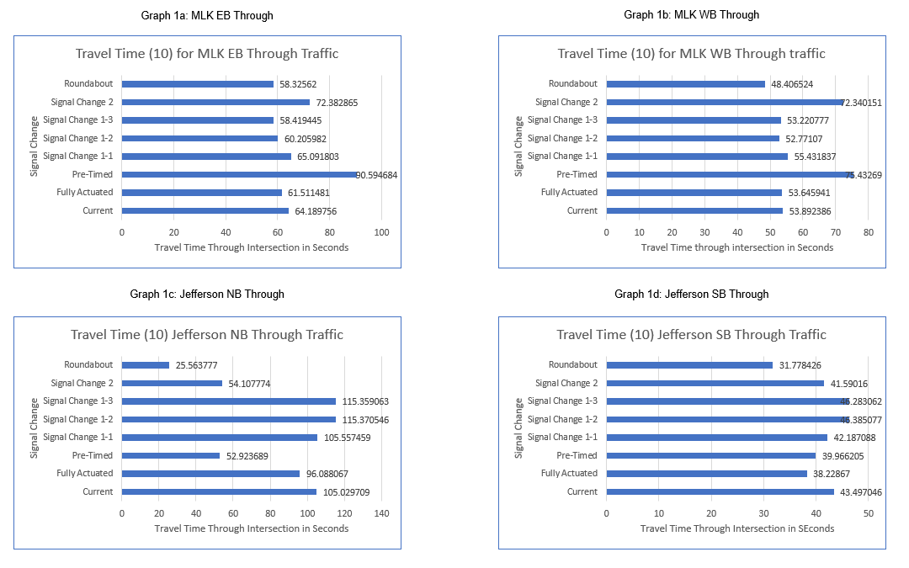

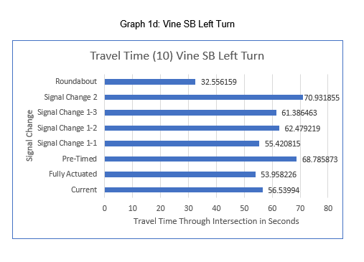

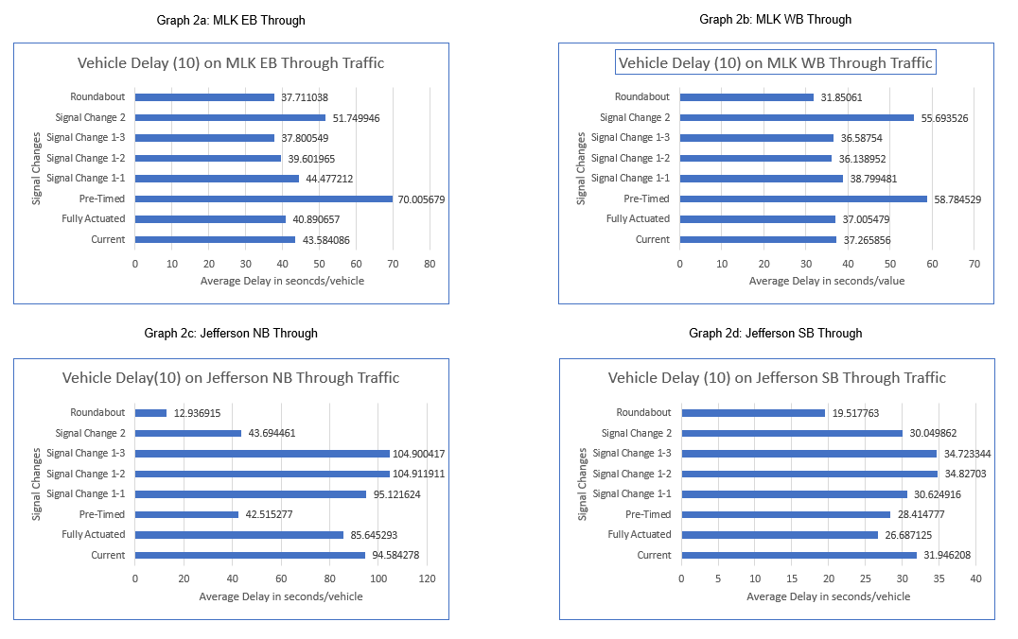**Graphs 2a – 2e: Vehicle Delay Comparison**

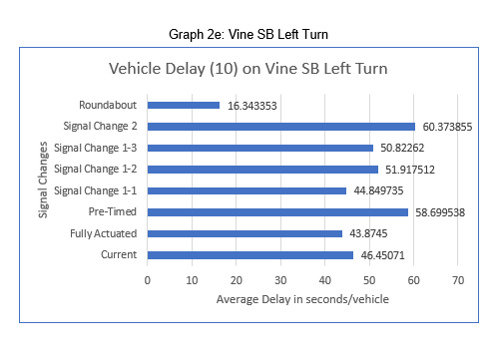

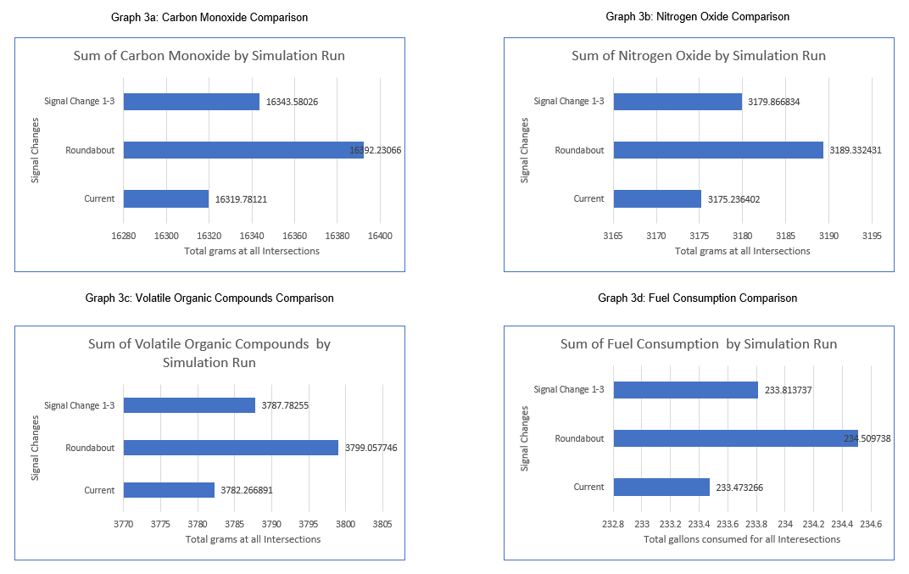**Graphs 3a-3d: Environmental Impact Comparisons**

**14.** **APPENDIX IV: TEACHING UNIT PLANS**

**14.1 Mrs. Lynn Brant’s Unit and Activity Plans**

|  |  |  |
| --- | --- | --- |
| **Name: Lynn M. Brant** | **Contact Info: lbrant@kingslocal.net** | **Date: 07/12/2019** |

|  |
| --- |
| **Unit Number and Title: 1 Circles and Revolving Doors** |

|  |  |
| --- | --- |
| **Grade Level:** | 10 - 11 |

|  |  |
| --- | --- |
| **Subject Area:** | Geometry |

|  |  |
| --- | --- |
| **Total Estimated Duration of Entire Unit:** | 8 days |

**Part 1: Designing the Unit**

|  |
| --- |
| 1. **Unit Academic Standards (**Identify which standards:NGSS, OLS and/or CCSS.Cut and paste from NGSS, OLS and/or CCSS and be sure to include letter and/or number identifiers.**):** |

*Ohio’s Department of Education’s Model Curriculum – High School Geometry Course*

G.C.2 Identify and describe relationships among angles, radii, chords, tangents, and arcs and use them to solve problems.

G.C.5 Find arc lengths and areas of sectors of circles.

G.CO.14 Classify two-dimensional figures in a hierarchy based on properties

G.MG.1 Use geometric shapes, their measures, and their properties to describe objects, e.g., modeling a tree trunk or a human torso as a cylinder

G.MG.3 Apply geometric methods to solve design problems, e.g., designing an object or structure to satisfy physical constraints or minimize cost; working with typographic grid systems based on ratios

*Mathematical Thinking Standards*

* Use accurate mathematical vocabulary.
* Make connections between concepts, terms, and properties.
* Recognize, apply, and justify mathematical concepts, terms, and their properties.
* Solve mathematical and real-world problems accurately.
* Determine reasonableness of results.
* Consider mathematical units involved in a problem.
* Make sound decisions about using tools.

|  |
| --- |
| 1. **Unit Summary** |

The Big Idea (including global relevance):

Circles – using Circles to model revolving doors

Revolving doors help transport people efficiently and help conserve energy. In a school setting, a revolving door could help eliminate bus emissions from entering the school building.

The (anticipated) Essential Questions: List 3 or more questions your students are likely to generate on their own. (Highlight in yellow the one selected to define the Challenge):

1. Are there different types of revolving doors?
2. What are the criteria of an efficient revolving door?
3. How big does the circular base of the door need to be to transport people?
4. How quickly does a revolving door rotate?
5. How many people can move through a revolving door at one time?
6. How can we model an efficient revolving door for the new entrance to Kings High School?

|  |
| --- |
| 1. **Unit Context** |

Justification for Selection of Content– Check all that apply:

**X** Students previously scored poorly on standardized tests, end-of term test or any other test given in the school or district on this content.

☐ Misconceptions regarding this content are prevalent.

**X** Content is suited well for teaching via CBL and EDP pedagogies.

☐ The selected content follows the pacing guide for when this content is scheduled to be taught during the school year. (Unit 1 covers atomic structure because it is taught in October when I should be conducting my first unit.)

☐ Other reason(s) _____________________________________________________________

_____________________________________________________________________________

The Hook: (Describe in a few sentences how you will use a “hook” to introduce the Big Idea in a compelling way that draws students into the topic.)

* Using my RET Industrial partner, I will have Qingyi Ai come give a presentation about roundabouts used as traffic control designs.
* I will then share with students the design of the three roundabouts that were recently developed in our school district with the implications of driving (or soon to be driving).
* I will share the traffic count from the roadway in front of our school and my research experience.
* Students will brainstorm other modern designs that involve circles and are used for transporting people.
* Students will do a broken research study of the article “The Ins and Outs of Revolving Doors.” Each group will be assigned a section and then report back to the class on their findings.
* Using a community partner, I am hoping to coordinate a salesman from Southern Ohio Door Controls as a guest speaker to discuss the questions he asks potential revolving door customers. It will also expose students to the vast array of careers that companies hire.

The Challenge and Constraints:

**X** Product **or** ☐ Process (Check one)

|  |  |
| --- | --- |
| Description of Challenge (Either Product or Process is clearly explained below): | List the Constraints Applied |
| Students will design an efficient revolving door and make a model from a given circular base to be the new doorway design for the proposed Kings High School re-model.  Students will make a model of their final design.  Students will then present their models in a 2-minute sale pitch with intended audience being the Kings Local School Board. Presentation must include the dimensions of the real-life entrance, including arclength of each door piece, area of sector, and circumference of the circular base.  Class will vote on most reasonable design based off real-life dimensions and efficiency in transporting people with an analysis of the amount of glass required (costs).  Best design from each class will be sent to 3-D printing. | 1. Time 2. Material provided for construction 3. Circular base size provided to each group 4. Model must allow people to move through doorway when scaled to real-life dimensions. |

Teacher’s Anticipated Guiding Questions (that apply to the Challenge and may change with student input.):

1. How can we model a revolving door?
2. Are there different types of revolving doors?
3. What should the area of a door sector be to accommodate people?
4. Who or what does the door have to transport?
5. Where can we find out about how revolving doors are designed?
6. Does the arclength impact the efficiency of the door?
7. How many sections is reasonable for a revolving door?
8. With a given circular base, what scale and units should be used for the model?
9. What safety factors need to be taken into consideration when designing a revolving door?
10. If the door is automatic, how quickly does it spin?
11. Is there a way to make the entrance secure with a revolving door?

|  |
| --- |
| **4. EDP: Use the diagram below to help you complete this section.** |

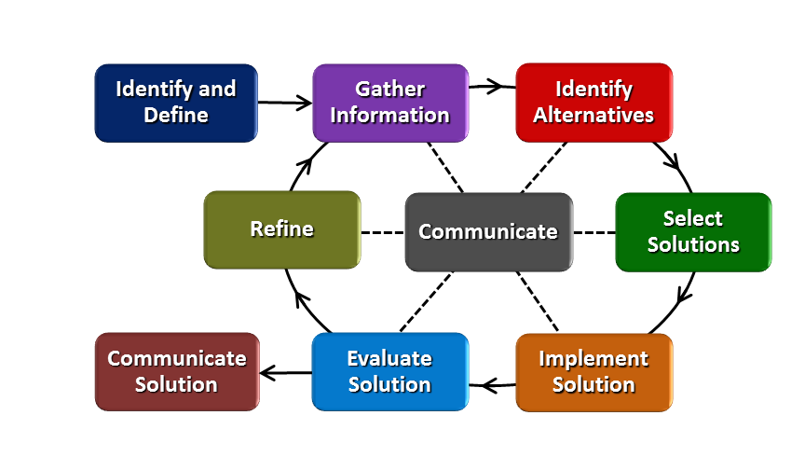

**How will students test or implement the solution? What is the evidence that the solution worked? Describe how the iterative process from the EDP applies to your Challenge.**

Once students have completed their model, they will present their model explaining the dimensions for a life-size door and justify how well it transports people into the school building. Evidence that the solution worked will be if the modeled sector is large enough to transport people into the building with an analysis of how much glass required (cost).

Due to time constraints, students will be required to show their calculations and provide written explanation of how they would change their model to make it a correct sized revolving door that would transport people efficiently.

**How will students present or defend the solution? Describe if any formal training or resource guides will be provided to the students for best practices (e.g., poster, flyer, video, advertisement, etc.) used to present work.**

Each team will do a 2-minute presentation showing their model and presenting it as the best revolving door design for the new high school entrance. The premise will be that they are selling the idea to the Kings Local School Board that only allows 2-minute public participation at meetings.

**What academic content is being taught through this Challenge?**

Students will be using the vocabulary of circles in creating the revolving door. The measurements of circumference and area, along with the proportional practice from the similarity unit will be emphasized. There will also be some concern for central angles and what degree provides the most efficient transportation of people. By modeling real-world situations, students will be applying many of the mathematical thinking skills that get lost in text book problems, such as determining reasonableness of results.

**Assessment and EDP:**

Using the diagram above, identify any places in the EDP where assessments should take place, as it applies to your Challenge. Describe below what kinds of assessment are most appropriate.

|  |  |
| --- | --- |
| What EDP Processes are ideal for conducting an Assessment? (List ones that apply.) | List the type of Assessment (Rubric, Diagram, Checklist, Model, Q/A etc.) Check box to indicate whether it is formative or summative. |
| Gather Information  Select Solution  Implement Solution  Evaluate Solution  Communicate Solutions | Two Interesting Post-it Facts **X** formative ☐ summative  Diagram ☐ formative **X** summative  Justification of math measurements **X** formative ☐ summative  Model of Final Solution ☐ formative **X** summative  Presentation (Rubric) ☐ formative **X** summative |

Check below which characteristic(s) of this Challenge will be incorporated in its implementation using EDP. (Check all that apply.)

**X** Has clear constraints that limit the solutions

**X** Will produce more than one possible solution that works

**X** Includes the ability to refine or optimize solutions

**X** Assesses science or math content

**X** Includes Math applications

☐ Involves use of graphs

**X** Requires analysis of data

**X** Includes student led communication of findings

|  |
| --- |
| **5. ACS (Real world applications; career connections; societal impact):** |

Place an X on the continuum to indicate where this Challenge belongs in the context of real world applications:

|  |  |  |
| --- | --- | --- |
| **Abstract or Loosely Applies to the Real World** | **|--------------------------------------|----------------------** **X ---------------|** | **Strongly Applies to the Real World** |

Provide a brief rationale for where you placed the X**:­­­­­­­­­­­­­­**

Students are creating a model for a potential new entrance into Kings High School.

What activities in this Unit apply to real world context?

Activity 3 (research/guest speakers); Activity 4 (challenge)

Place an X on the continuum to indicate where this Challenge belongs in the context of societal impact:

|  |  |  |
| --- | --- | --- |
| **Shows Little or No Societal Impact** | **|-------------------------------------|-----** **X --------------------------------|** | **Strongly Shows Societal Impact** |

Provide a brief rationale for where you placed the X**: ­­­­­­­­­­­­­­**

While the science concepts behind a revolving door are not the main focus of the challenge, students will make the connections to roundabouts being built for road safety and revolving doors being built for saving energy and keeping bus emissions out of the school building.

What activities in this Unit apply to societal impact?

Activity 3 (research/guest speakers)

Careers: What careers will you introduce (and how) to the students that are related to the Challenge? (Examples: career research assignment, guest speakers, fieldtrips, Skype with a professional, etc.)

Through the RET industrial partner speaking in my classroom, my students will be exposed to civil engineering and transportation engineering. The salesman from the revolving door company will introduce students to careers in the business world, along with showing another side of engineering.

|  |
| --- |
| **6. Misconceptions:** |

* Revolving doors are only used for aesthetic value in buildings.
* The measure of an arc is equal to the measure of the corresponding central angle.
* Arclength is expressed in linear measure; measure of the arc is in degrees.
* If the radius of the circle is scaled by $k$, the corresponding arc length is multiplied by $k$ and the sector area is multiplied by $k^{2}$.

|  |
| --- |
| **7. Unit Lessons and Activities: (**Provide a tentative timeline with a breakdown for Lessons 1 and 2. Provide the Lesson #’s and Activity #’s for when the Challenge Based Learning (CBL) and Engineering Design Process (EDP) are embedded in the unit.) |

Lesson #1: Exploring the Use of Circles in Real-life

Students will explore the use of circles in our world and understand their relevance in geometry.

Activity 1: Tower Power! (1 day)

* Engineering Design Process as a way to approach Geometry problems
* Group Roles
* Design Nets…including circles from cylinders

Activity 2: 30 Circle Brainstorms (10-15 minutes on 3 different days)

* Individual Brainstorm of where circles are used in the world
* Geometry Pre-test of vocabulary and theorems inside 30 circles
* Group Brainstorm of real-life objects that are circular in nature and move things
* Share my personal brainstorm which includes Traffic Lights, Roundabouts, and Revolving Doors leading into my summer experience with the RET program
* Research: one post-it note fact about Roundabouts and one post-it note fact about revolving doors

Lesson #2: Challenge-Based Learning

Students will work on the challenge of designing a revolving door as a new entrance to Kings HS.

Activity 3: Guest Speakers – Roundabout Safety/Revolving Door Company (3 days)

* Hook – transporting cars safely and efficiently; transporting people safely and efficiently
* Big Idea – using circles to model revolving doors
* Essential Question- How can we model an efficient revolving door for the new entrance to Kings High School?
* Students will do a broken research study of the article “The Ins and Outs of Revolving Doors.” Each group will be assigned a section and then report back to the class on their findings.

Activity 4: Let’s Build a Revolving Door Model (3 days)

* Challenge – Design a model of a revolving door as an entrance to Kings HS

1. Given a circular container for base of door
2. Design ideas from group; vote on one to build
3. Test design & calculate size to give proportionality between model and real-life

* Presentation – Sell your model to the Kings Local School Board in a 2-minute presentation

|  |
| --- |
| **8. Keywords:** |

revolving door, modeling, civil engineering, construction engineering, traffic engineering, roundabouts

|  |
| --- |
| **9. Additional Resources:** |

* Who invented the revolving door?

<https://science.howstuffworks.com/innovation/everyday-innovations/who-invented-the-revolving-door1.htm>

* Buildings Benefit from Revolving Doors

<https://lacrossetribune.com/community/tomahjournal/lifestyles/buildings-benefit-from-revolving-doors/article_060dbc56-2160-11e3-bea3-0019bb2963f4.html>

* Whitepaper “The Ins and Outs of Revolving Doors”

<https://www.constructionspecifier.com/the-ins-and-outs-of-revolving-doors/>

|  |
| --- |
| **10. Pre-Unit and Post-Unit Assessment Instruments:** |

1.1.2a Circles_Pre-Test_lbrant_071219

|  |  |
| --- | --- |
| **11. Poster** | **12. Video (Link here.)** |

**If you are a science teacher, check the boxes below that apply:**

| **Next Generation Science Standards (NGSS)** | |
| --- | --- |
| **Science and Engineering Practices (Check all that apply)** | **Crosscutting Concepts (Check all that apply)** |
| ☐ Asking questions (for science) and defining problems (for engineering) | ☐ Patterns |
| ☐ Developing and using models | ☐ Cause and effect |
| ☐ Planning and carrying out investigations | ☐ Scale, proportion, and quantity |
| ☐ Analyzing and interpreting data | ☐ Systems and system models |
| ☐ Using mathematics and computational thinking | ☐ Energy and matter: Flows, cycles, and conservation |
| ☐ Constructing explanations (for science) and designing solutions (for engineering) | ☐ Structure and function. |
| ☐ Engaging in argument from evidence | ☐ Stability and change. |
| ☐ Obtaining, evaluating, and communicating information |  |

**If you are a science teacher, check the boxes below that apply:**

| **Ohio’s Learning Standards for Science (OLS)** |
| --- |
| **Expectations for Learning - Cognitive Demands (Check all that apply)** |
| ☐ Designing Technological/Engineering Solutions Using Science concepts **(T)** |
| ☐ Demonstrating Science Knowledge **(D)** |
| ☐ Interpreting and Communicating Science Concepts **(C)** |
| ☐ Recalling Accurate Science **(R)** |

**If you are a math teacher, check the boxes below that apply:**

| **Ohio’s Learning Standards for Math (OLS) or**  **Common Core State Standards -- Mathematics (CCSS)** | |
| --- | --- |
| **Standards for Mathematical Practice (Check all that apply)** | |
| **X** Make sense of problems and persevere in solving them | ☐ Useappropriate tools strategically |
| ☐ Reason abstractly and quantitatively | **X** Attendto precision |
| **X** Construct viable arguments and critique the reasoning of others | **X** Look for and make use of structure |
| **X** Model with mathematics | ☐ Look for and express regularity in repeated reasoning |

**Part 2: Post Implementation- Reflection on the Unit**

|  |
| --- |
| **Results: Evidence of Growth in Student Learning -** After the Unit has been taught and the Post-Unit Assessment Instrument has been used to assess student growth in learning, the teacher must analyze the data and determine whether or not student growth in learning occurred. Present all documents used to collect and organize Post- Unit evaluation data such as graphs or charts. Provide a written analysis in sentence or paragraph form which provides the evidence that student growth in learning took place. Please present results and, if applicable, student work (as a hyperlink) used as evidence after the Unit has been taught.  **Please include**:   * Any documents used to collect and organize post unit evaluation data. (charts, graphs and /or tables etc.) * An analysis of data used to measure growth in student learning providing evidence that student learning occurred. (Sentence or paragraph form.) * Other forms of assessment that demonstrate evidence of learning. * Anecdotal information from student feedback. |

|  |
| --- |
| **Reflection: Reflections: Reflect upon the successes of teaching in this Unit in 5 or more sentences in the form of a narrative. Consider the following questions:**   1. Why did you select this content for the Unit? 2. Was the purpose for selecting the Unit met? If yes, provide student learning related evidence. If not, provide possible reasons. 3. Did the students find a solution or solutions that resulted in concrete meaningful action for the Unit’s Challenge? Hyperlink examples of student solutions as evidence. 4. What does the data indicate about growth in student learning? 5. What would you change if you re-taught this Unit? 6. Would you teach this Unit again? Why or why not? |

|  |  |  |
| --- | --- | --- |
| **Name: Lynn M. Brant** | **Contact Info: lbrant@kingslocal.net** | **Date: 06/27/2019** |

|  |  |  |  |
| --- | --- | --- | --- |
| **Lesson 1: Exploring the Use of Circles in Real-life** | **Unit #:**  **1** | **Lesson #:**  **1** | **Activity #:**  **1** |
| **Activity: 1.1.1 Tower Power!** |

|  |  |
| --- | --- |
| **Estimated Lesson Duration:** | **4 days** |
| **Estimated Activity Duration:** | **1 class period (50 minutes)** |

|  |  |
| --- | --- |
| **Setting:** | **Kings High School Room A208** |

|  |
| --- |
| **Activity Objectives:** |

1. Students will be able to understand the Engineering Design Process (EDP).
2. Students will be able to determine what gives circular objects strength.
3. Students will be able to draw a net of a three-dimensional object.

|  |
| --- |
| **Activity Guiding Questions:** |

* What possible shapes are towers?
* What type of tower will provide the most strength?
* How does the size of the circle affect the strength of the tower?

| **Next Generation Science Standards (NGSS)** | |
| --- | --- |
| **Science and Engineering Practices (Check all that apply)** | **Crosscutting Concepts (Check all that apply)** |
| Asking questions (for science) and defining problems (for engineering) | Patterns |
| Developing and using models | Cause and effect |
| Planning and carrying out investigations | Scale, proportion, and quantity |
| Analyzing and interpreting data | Systems and system models |
| Using mathematics and computational thinking | Energy and matter: Flows, cycles, and conservation |
| Constructing explanations (for science) and designing solutions (for engineering) | Structure and function. |
| Engaging in argument from evidence | Stability and change. |
| Obtaining, evaluating, and communicating information |  |

| **Ohio’s Learning Standards for Science (OLS)** |
| --- |
| **Expectations for Learning - Cognitive Demands (Check all that apply)** |
| Designing Technological/Engineering Solutions Using Science concepts **(T)** |
| Demonstrating Science Knowledge **(D)** |
| Interpreting and Communicating Science Concepts **(C)** |
| Recalling Accurate Science **(R)** |

| **Ohio’s Learning Standards for Math (OLS) and/or**  **Common Core State Standards -- Mathematics (CCSS)** | |
| --- | --- |
| **Standards for Mathematical Practice (Check all that apply)** | |
| Make sense of problems and persevere in solving them | Useappropriate tools strategically |
| Reason abstractly and quantitatively | Attendto precision |
| Construct viable arguments and critique the reasoning of others | Look for and make use of structure |
| Model with mathematics | Look for and express regularity in repeated reasoning |

|  |
| --- |
| **Unit Academic Standards (NGSS, OLS and/or CCSS):** |

* G.CO.14 Classify two-dimensional figures in a hierarchy based on properties
* G.MG.1 Use geometric shapes, their measures, and their properties to describe objects, e.g., modeling a tree trunk or a human torso as a cylinder
* G.MG.3 Apply geometric methods to solve design problems, e.g., designing an object or structure to satisfy physical constraints or minimize cost; working with typographic grid systems based on ratios

|  |
| --- |
| **Materials**: (Link Handouts, Power Points, Resources, Websites, Supplies) |

* Group Roles (1.1.1a Circles_Tower Power Roles_lbrant_071219)
* Cardboard
* Loose leaf paper
* Coffee stirrers
* Chewing gum
* Rulers
* Scissors
* Scotch Tape
* Stopwatch
* Stack of Textbooks
* Engineering Design Handout (1.1.1b Circles_EDP_lbrant_071219)

|  |
| --- |
| **Teacher Advance Preparation:** |

* Supply table
* Deck of Cards for random assigning of group
* Copies of Group Roles separated for student selection
* Copies of Engineering Design Handout

|  |
| --- |
| **Activity Procedures:** |

1. Groups assigned by selecting from a deck of cards
2. Assign Group Roles: Director, Technician, Facilitator, Materials Manager
3. Students will design a tower of power with the given supplies to meet these constraints/criteria:
   1. Tower must be at least 11 inches in height.
   2. Tower must be ready to test in 15 minutes.
   3. Winning tower will be able to hold the most textbooks for at least 10 seconds.
4. Test the groups by adding textbooks at the same time for each group.
5. Introduce the Engineering Design Process through handout.
6. Group Reflection: Drawing of tower, including net, and indicating if they naturally used any pieces of the EDP.

**Formative Assessments:** Link the items in the Activities that will be used as formative assessments.

* Group drawing of tower and reflection on each phase of the EDP.
* Class observation of students preparing the tower.

**Summative Assessments:** These are optional; there may be summative assessments at the end of a set of Activities or only at the end of the entire Unit.

|  |
| --- |
| **Differentiation:** Describe how you modified parts of the Lesson to support the needs of different learners.  Refer to Activity Template for details. |

|  |
| --- |
| **Reflection:** Reflect upon the successes and shortcomings of the lesson. |

|  |  |  |
| --- | --- | --- |
| **Name: Lynn M. Brant** | **Contact Info: lbrant@kingslocal.net** | **Date: 06/27/2019** |

|  |  |  |  |
| --- | --- | --- | --- |
| **Lesson 1: Exploring the Use of Circles in Real-life** | **Unit #:**  **1** | **Lesson #:**  **1** | **Activity #:**  **2** |
| **Activity: 1.1.2 Thirty Circles Brainstorms** |

|  |  |
| --- | --- |
| **Estimated Lesson Duration:** | **4 days** |
| **Estimated Activity Duration:** | **10 – 15 minutes on 3 different days** |

|  |  |
| --- | --- |
| **Setting:** | **Kings High School Room A208** |

|  |
| --- |
| **Activity Objectives:** |

1. Students will individually brainstorm how circles are used in our world by completing as many circles with object drawings in 5 minutes.
2. Students will demonstrate past knowledge on circles through a 30 circles pre-test.
3. Students will brainstorm with a group using the 30 circles to develop where circles have been used to transport items.
4. Students will develop the Big Idea that revolving doors are circles that transport people efficiently and help conserve energy.
5. Students will independently research one post-it note fact about roundabouts and one post-it note fact about revolving doors to prepare for next activity.

|  |
| --- |
| **Activity Guiding Questions:** |

* Where are circles observed in our world?
* Why is it important we study circles?
* How are circles used to help put our world in motion?

| **Next Generation Science Standards (NGSS)** | |
| --- | --- |
| **Science and Engineering Practices (Check all that apply)** | **Crosscutting Concepts (Check all that apply)** |
| Asking questions (for science) and defining problems (for engineering) | Patterns |
| Developing and using models | Cause and effect |
| Planning and carrying out investigations | Scale, proportion, and quantity |
| Analyzing and interpreting data | Systems and system models |
| Using mathematics and computational thinking | Energy and matter: Flows, cycles, and conservation |
| Constructing explanations (for science) and designing solutions (for engineering) | Structure and function. |
| Engaging in argument from evidence | Stability and change. |
| Obtaining, evaluating, and communicating information |  |

| **Ohio’s Learning Standards for Science (OLS)** |
| --- |
| **Expectations for Learning - Cognitive Demands (Check all that apply)** |
| Designing Technological/Engineering Solutions Using Science concepts **(T)** |
| Demonstrating Science Knowledge **(D)** |
| Interpreting and Communicating Science Concepts **(C)** |
| Recalling Accurate Science **(R)** |

| **Ohio’s Learning Standards for Math (OLS) and/or**  **Common Core State Standards -- Mathematics (CCSS)** | |
| --- | --- |
| **Standards for Mathematical Practice (Check all that apply)** | |
| Make sense of problems and persevere in solving them | Useappropriate tools strategically |
| Reason abstractly and quantitatively | Attendto precision |
| Construct viable arguments and critique the reasoning of others | Look for and make use of structure |
| Model with mathematics | Look for and express regularity in repeated reasoning |

|  |
| --- |
| **Unit Academic Standards (NGSS, OLS and/or CCSS):** |

* G.C.2 Identify and describe relationships among angles, radii, chords, tangents, and arcs and use them to solve problems.
* G.C.5 Find arc lengths and areas of sectors of circles.

|  |
| --- |
| **Materials**: (Link Handouts, Power Points, Resources, Websites, Supplies) |

* 30 Circle Worksheet (1.1.2a Circles_Thirty Circles Brainstorm_lbrant_071219)
* Pre-test of Circle Unit including vocabulary, theorems, and formulas
* Large Post-it posters for Scattergories
* Small Post-it notes for research facts

|  |
| --- |
| **Teacher Advance Preparation:** |

* Copies of 30 Circle Worksheet
* Copies of Pre-Test

|  |
| --- |
| **Activity Procedures:** |

1. Individual brainstorm of circular objects in our world
2. Pre-test of Circle Vocabulary and theorems related to angles inside circles
3. Group brainstorm of real-life circular objects that help us move
   1. Scattergories to reveal all class ideas
   2. Lead to roundabouts and revolving doors
   3. Potential of needing them at KHS
   4. Post-it Note Research: one fact about roundabouts and one about revolving doors

**Formative Assessments:** Link the items in the Activities that will be used as formative assessments.

* Class observation of brainstorming activity
* Pre-Test of circle knowledge
* Scattergories for group brainstorm
* Submission of Post-it Note facts from research homework

**Summative Assessments:** These are optional; there may be summative assessments at the end of a set of Activities or only at the end of the entire Unit.

|  |
| --- |
| **Differentiation:** Describe how you modified parts of the Lesson to support the needs of different learners.  Refer to Activity Template for details. |

|  |
| --- |
| **Reflection:** Reflect upon the successes and shortcomings of the lesson. |

|  |  |  |
| --- | --- | --- |
| **Name: Lynn M. Brant** | **Contact Info: lbrant@kingslocal.net** | **Date: 06/27/2019** |

|  |  |  |  |
| --- | --- | --- | --- |
| **Lesson 2: Challenge Based Learning** | **Unit #:**  **1** | **Lesson #:**  **2** | **Activity #:**  **1** |
| **Activity: 1.2.1 Big Idea/Hook through Guest Speakers** |

|  |  |
| --- | --- |
| **Estimated Lesson Duration:** | **5 days** |
| **Estimated Activity Duration:** | **2 days** |

|  |  |
| --- | --- |
| **Setting:** | **Kings High School Room A208** |

|  |
| --- |
| **Activity Objectives:** |

1. Students will listen to Industrial Partner about development of roundabouts in the Kings Local School District to understand the many considerations of transporting people safely and efficiently.
2. Students will develop Essential Questions following the connection of roundabouts to Mrs. Brant’s summer research and the traffic data collected from Columbia Road to prepare for re-modeling of Kings High School.
3. Students will be guided into the following Essential Question: How can we model an efficient revolving door for the new entrance to Kings High School.
4. Students will interact with a revolving door salesperson to answer questions and provoke input in the challenge and the design of their revolving door.

|  |
| --- |
| **Activity Guiding Questions:** |

* How can we model a revolving door?
* Are there different types of revolving doors?
* What are the criteria of an efficient revolving door?
* How much area is needed for the sector to transport people?
* How quickly do automatic doors spin?
* How many people can pass through a revolving door in one revolution?
* Are all revolving doors automatic?

| **Next Generation Science Standards (NGSS)** | |
| --- | --- |
| **Science and Engineering Practices (Check all that apply)** | **Crosscutting Concepts (Check all that apply)** |
| Asking questions (for science) and defining problems (for engineering) | Patterns |
| Developing and using models | Cause and effect |
| Planning and carrying out investigations | Scale, proportion, and quantity |
| Analyzing and interpreting data | Systems and system models |
| Using mathematics and computational thinking | Energy and matter: Flows, cycles, and conservation |
| Constructing explanations (for science) and designing solutions (for engineering) | Structure and function. |
| Engaging in argument from evidence | Stability and change. |
| Obtaining, evaluating, and communicating information |  |

| **Ohio’s Learning Standards for Science (OLS)** |
| --- |
| **Expectations for Learning - Cognitive Demands (Check all that apply)** |
| Designing Technological/Engineering Solutions Using Science concepts **(T)** |
| Demonstrating Science Knowledge **(D)** |
| Interpreting and Communicating Science Concepts **(C)** |
| Recalling Accurate Science **(R)** |

| **Ohio’s Learning Standards for Math (OLS) and/or**  **Common Core State Standards -- Mathematics (CCSS)** | |
| --- | --- |
| **Standards for Mathematical Practice (Check all that apply)** | |
| Make sense of problems and persevere in solving them | Useappropriate tools strategically |
| Reason abstractly and quantitatively | Attendto precision |
| Construct viable arguments and critique the reasoning of others | Look for and make use of structure |
| Model with mathematics | Look for and express regularity in repeated reasoning |

|  |
| --- |
| **Unit Academic Standards (NGSS, OLS and/or CCSS):** |

*Mathematical Thinking Standards*

* Use accurate mathematical vocabulary.
* Make connections between concepts, terms, and properties.
* Recognize, apply, and justify mathematical concepts, terms, and their properties.
* Solve mathematical and real-world problems accurately.
* Determine reasonableness of results.
* Consider mathematical units involved in a problem.
* Make sound decisions about using tools.

|  |
| --- |
| **Materials**: (Link Handouts, Power Points, Resources, Websites, Supplies) |

|  |
| --- |
| **Teacher Advance Preparation:** |

* Scheduling of guest speakers
* Obtaining video-taping equipment for guest speakers’ presentations

|  |
| --- |
| **Activity Procedures:** |

1. In order to hook students to the challenge, our Industrial Partner will come as a guest speaker about roundabouts in Kings Local School District. He will discuss their efficiency and safety and the reason United States has started building roundabouts.
2. Through connecting Mrs. Brant’s summer research and the traffic data from the Columbia Road, students will be guided to the big idea and essential question of transporting people into Kings High School through a revolving door.
3. With the help of a spokesperson from a revolving door company, students will develop guiding questions about revolving doors.

**Formative Assessments:** Link the items in the Activities that will be used as formative assessments

* Class observation of questions for guest speaker.

**Summative Assessments:** These are optional; there may be summative assessments at the end of a set of Activities or only at the end of the entire Unit.

|  |
| --- |
| **Differentiation:** Describe how you modified parts of the Lesson to support the needs of different learners.  Refer to Activity Template for details. |

|  |
| --- |
| **Reflection:** Reflect upon the successes and shortcomings of the lesson. |

|  |  |  |
| --- | --- | --- |
| **Name: Lynn M. Brant** | **Contact Info:** [lbrant@kingslocal.net](mailto:lbrant@kingslocal.net) | **Date: 06/27/2019** |

|  |  |  |  |
| --- | --- | --- | --- |
| **Lesson 2: Challenge Based Learning** | **Unit #:**  **1** | **Lesson #:**  **2** | **Activity #:**  **2** |
| **Activity: 1.2.2 Building the Revolving Door** |

|  |  |
| --- | --- |
| **Estimated Lesson Duration:** | **5 days** |
| **Estimated Activity Duration:** | **3 days** |

|  |  |
| --- | --- |
| **Setting:** | **Kings High School Room A208** |

|  |
| --- |
| **Activity Objectives:** |

1. Students will be able to design a model of a revolving door through using appropriate units and scaling from a given circular base.
2. If time permits, students will refine their design or provide a written description of what changes their design needs to be efficient and properly scaled to transport people.
3. Students will communicate their solution through a 2 minute presentation with intended audience being the Kings Local School District Board.
4. Students will demonstrate growth in knowledge of circle vocabulary, measurements, and theorems on the post-test.

|  |
| --- |
| **Activity Guiding Questions:** |

* How can we model a revolving door?
* Are there different types of revolving doors?
* What are the criteria of an efficient revolving door?
* How much area is needed for the sector to transport people?
* Are all revolving doors automatic?
* What scale factor should we use to make our model a realistic size?

| **Next Generation Science Standards (NGSS)** | |
| --- | --- |
| **Science and Engineering Practices (Check all that apply)** | **Crosscutting Concepts (Check all that apply)** |
| Asking questions (for science) and defining problems (for engineering) | Patterns |
| Developing and using models | Cause and effect |
| Planning and carrying out investigations | Scale, proportion, and quantity |
| Analyzing and interpreting data | Systems and system models |
| Using mathematics and computational thinking | Energy and matter: Flows, cycles, and conservation |
| Constructing explanations (for science) and designing solutions (for engineering) | Structure and function. |
| Engaging in argument from evidence | Stability and change. |
| Obtaining, evaluating, and communicating information |  |

| **Ohio’s Learning Standards for Science (OLS)** |
| --- |
| **Expectations for Learning - Cognitive Demands (Check all that apply)** |
| Designing Technological/Engineering Solutions Using Science concepts **(T)** |
| Demonstrating Science Knowledge **(D)** |
| Interpreting and Communicating Science Concepts **(C)** |
| Recalling Accurate Science **(R)** |

| **Ohio’s Learning Standards for Math (OLS) and/or**  **Common Core State Standards -- Mathematics (CCSS)** | |
| --- | --- |
| **Standards for Mathematical Practice (Check all that apply)** | |
| Make sense of problems and persevere in solving them | Useappropriate tools strategically |
| Reason abstractly and quantitatively | Attendto precision |
| Construct viable arguments and critique the reasoning of others | Look for and make use of structure |
| Model with mathematics | Look for and express regularity in repeated reasoning |

|  |
| --- |
| **Unit Academic Standards (NGSS, OLS and/or CCSS):** |

* G.C.2 Identify and describe relationships among angles, radii, chords, tangents, and arcs and use them to solve problems.
* G.C.5 Find arc lengths and areas of sectors of circles.
* G.CO.14 Classify two-dimensional figures in a hierarchy based on properties
* G.MG.1 Use geometric shapes, their measures, and their properties to describe objects, e.g., modeling a tree trunk or a human torso as a cylinder
* G.MG.3 Apply geometric methods to solve design problems, e.g., designing an object or structure to satisfy physical constraints or minimize cost; working with typographic grid systems based on ratios

*Mathematical Thinking Standards*

* Use accurate mathematical vocabulary.
* Make connections between concepts, terms, and properties.
* Recognize, apply, and justify mathematical concepts, terms, and their properties.
* Solve mathematical and real-world problems accurately.
* Determine reasonableness of results.
* Consider mathematical units involved in a problem.
* Make sound decisions about using tools.

|  |
| --- |
| **Materials**: (Link Handouts, Power Points, Resources, Websites, Supplies) |

* Circular Base Containers- variety of butter, cool whip, ice cream, and other circular containers
* Materials for central vertical axis cylinder – dowel rods
* Materials for hinging door panels – cylindrical styrofoam
* Materials for door – fab lab blank gray stencil sheets for plastic
* Mini-Model Motors, battery cases, and AA batteries to put model in motion for demonstrating
* Hot glue guns and glue
* Team Boxes to store models
* Presentation Rubric
* Post Test

|  |
| --- |
| **Teacher Advance Preparation:** |

* Purchasing/Gathering Supplies
* Reserving Makers Space for modeling
* Presentation Rubric
* Post-Test

|  |
| --- |
| **Activity Procedures:** |

1. Students will be given random number assignment to select one of the provided circular bases.
2. Students will design the revolving door as a new entrance to Kings High School.
3. Students will select solutions and implement their solution into a model.
4. Students will use scale factors to build a scaled model of their revolving door solution.
5. Students will create a 2-minute presentation selling their model to the class and provide the dimensions of the real-life entrance, including arclength of each door sector, area of sector, and circumference of circular base.
6. Students will vote on best design based off of real-life measurements and efficiency of allowing students to enter the building. Final determining factor will be the amount of glass used to keep cost low.
7. Best design from each class will be sent to 3-D printing and possibly presented to Kings Local School Board.

**Formative Assessments:** Link the items in the Activities that will be used as formative assessments.

* Classroom observation of design phase
* Completed Scale Model
* Presentation Rubric

**Summative Assessments:** These are optional; there may be summative assessments at the end of a set of Activities or only at the end of the entire Unit.

* Post Test of Circular Objectives

|  |
| --- |
| **Differentiation:** Describe how you modified parts of the Lesson to support the needs of different learners.  Refer to Activity Template for details. |

|  |
| --- |
| **Reflection:** Reflect upon the successes and shortcomings of the lesson. |

**14.2 Dr. Girija Nair-Hart’s Unit and Activity Plans**



|  |  |  |
| --- | --- | --- |
| **Name: Girija Nair-Hart** | **Contact Info:** [**nairhaga@ucmail.uc.edu**](mailto:nairhaga@ucmail.uc.edu) | **Date: 7/9/2019** |

|  |
| --- |
| **Unit Number and Title:** Minimizing Internal Traffic Congestion and Vehicular Crash at the ‘Arterial Intersection’; The intersection of Artery, Capillary, and Veins. |

|  |  |
| --- | --- |
| **Grade Level:** | College |

|  |  |
| --- | --- |
| **Subject Area:** | Calculus 1 |

|  |  |
| --- | --- |
| **Total Estimated Duration of Entire Unit:** | Not sure |

**Part 1: Designing the Unit**

|  |  |
| --- | --- |
| 1. **Unit Academic Standards (**Identify which standards:NGSS, OLS and/or CCSS.Cut and paste from NGSS, OLS and/or CCSS and be sure to include letter and/or number identifiers.**):**   **Course Learning Outcomes**  The successful Calculus I student should be able to: 1.   Compute the derivative of a function using the limit definition and derivative theorems.  2.   Use the derivative to find tangent lines to a graph, find the slope of a graph at a point,          and compute the rate of change of a dependent variable with respect to an independent           variable.  3.   Determine absolute extrema on a closed interval for continuous functions and to use the          first and second derivatives to analyze and sketch the graph of a function.  4.   Compute indefinite and definite integrals using the Fundamental Theorem of Calculus and the          method of substitution.  5.   Use definite integrals to find areas of planar regions.  6.   Apply the competencies above to a wide range of functions, including polynomial, rational,          algebraic, trigonometric, inverse trigonometric, exponential, logarithmic, hyperbolic and          inverse hyperbolic.  **Course Objectives**  Creation and interpretation of mathematical models (such as formulas, graphs, tables, and schematics) and inferences from such models. Representation of mathematical notation (quantitative information symbolically, visually, numerically, and verbally.) Problem-solving using arithmetical, algebraic, geometric, logical, and/or statistical methods. Evaluation of solutions to mathematical problems (estimate, check answers, identify alternatives, select optimal results, and recognize the limits of the methods). | |
| 1. **Unit Summary** 2. In the beginning of the semester introduce the textbook problem relevant to the project. 3. Ask students to read the article *Blood Vessel Branching: Beyond the Standard Calculus Problem*/Adam so that students can understand the technical terms, derivation of the formulas 4. Understand the Poiseuille’s formula for the resistance R of blood 5. Students will examine a 3D printout of the Blood Vascular System 6. In groups of 4 students will build a vascular branching model. 7. They will take relevant measurements from their model and check whether their model has the optimal branching angle |

**The Big Idea (including global relevance): The big idea is the application of calculus in real life.**

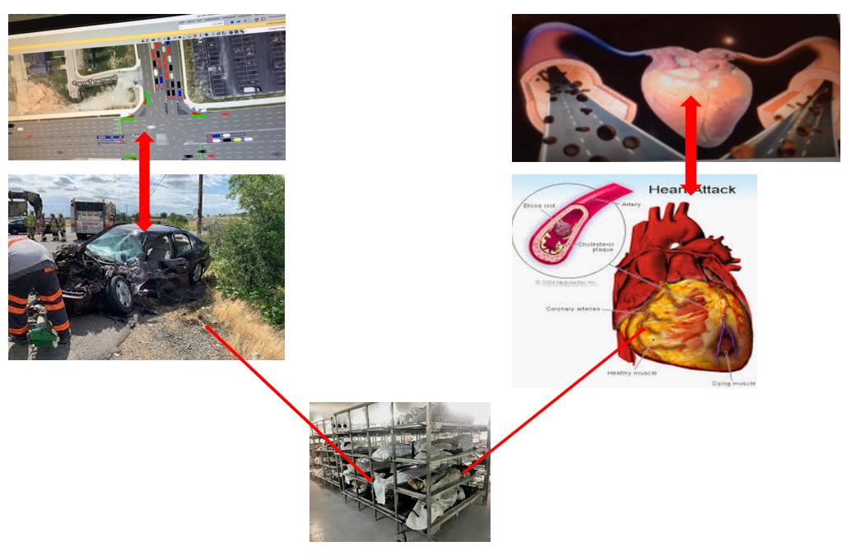

**Broader Perspective –** Application of Calculus in Real Life

The (anticipated) Essential Questions: List 3 or more questions your students are likely to generate on their own. (Highlight in yellow the one selected to define the Challenge):   
 1. What is the arterial make up?

2. How to find an equation connecting R to theta?

3. How are the variables of the arterial make up connected to the minimization of vehicle wait time?

|  |
| --- |
| 1. **Unit Context**   Optimization Techniques |

Justification for Selection of Content– Check all that apply:

☐ Students previously scored poorly on standardized tests, end-of term test or any other test given in the school or district on this content.

x Misconceptions regarding this content are prevalent.

x Content is suited well for teaching via CBL and EDP pedagogies.

☐ The selected content follows the pacing guide for when this content is scheduled to be taught during the school year. (Unit 1 covers atomic structure because it is taught in October when I should be conducting my first unit.)

☐ Other reason(s) Provides opportunities for multiple activities

The Hook: Decision between Life versus Death!

(Describe in a few sentences how you will use a “hook” to introduce the Big Idea in a compelling way that draws students into the topic.)

* General Knowledge

“The blood circulatory system (cardiovascular system) delivers nutrients and oxygen to all cells in the body. It consists of the heart and the blood vessels running through the entire body. The arteries carry blood away from the heart; the veins carry it back to the heart. The system of blood vessels resembles a tree: The “trunk” – the main artery (aorta) – branches into large arteries, which lead to smaller and smaller vessels. The smallest arteries end in a network of tiny vessels known as the capillary network.”

<https://www.ncbi.nlm.nih.gov/books/NBK279250/>

* Health Education

Diabetic education improved my attitude

People often call cardiovascular disease a "silent killer." This disease sneaks up and causes damage, but patients don't realize it—until serious symptoms start. That is why physicians recommend keeping your cardiovascular system healthy. A healthy cardiovascular system gives us the energy and the stamina to do all of the things that we want to accomplish, such as do our best in school and perform well in sports. But what makes a cardiovascular system unhealthy, and what are the factors that lead to problems like poor blood flow rate? In this life science project, you will build a model of the heart and the arteries with a bucket, tubes, and water to see what affects blood (water) flow rate. You will see what it takes to maintain a healthy heart and arteries.

(<https://www.sciencebuddies.org/science-fair-projects/project-ideas/HumBio_p032/human-biology-health/modeling-the-human-cardiovascular-system-blood-flow-rate>)

The Challenge: Creating a model of the Arterial Junction using the optimum angle/radius for smooth blood flow

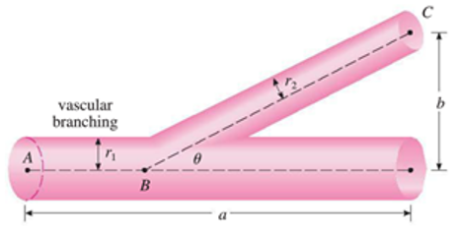

What is the optimum angle/radius for smooth flood flow?

x Product **or** ☐ Process

|  |  |
| --- | --- |
| Description of Challenge (Either Product or Process is clearly explained below): | List the Constraints Applied |
| Make a hole on the side of the bottle. Fit the tubing. Fill the bottle with liquid, adjust the valve speed to the preset number. Then adjust the angle between the bottle and the tubing so that the perception of ‘best flow’ is perceived.    Measure the variables theta, r1, r2, a, and b. Optimze theta using calculus for the measurements r1, r2, and a of their system they created. Measure the pre-analysis amount of water that was leaked out (v). Did they have the optimum angle? (and b) for the preset time interval and the preset valve speed. Adjust the angle to the maximum calue of theta computed using optimization technique. Repeat the experiment for the same time interval and measure (V) the volume of water that was leaked.Is V > v ? | Constraints: Types of materials used, type of liquid (viscocity), amount of liquid used, valve speed, the value of theta that it ought to be acute angle. The mesaurements. You may calculate theta as many times a syou need. |

Teacher’s Anticipated Guiding Questions (that apply to the Challenge and may change with student input.):

(Given this challenge what question students may ask?)

Do you want to select your own partners?

Who is going to keep all the measurements?

Who is going to take the measurements?

Who will distribute the supplies?

Who will do the clean up?

|  |
| --- |
| **4. EDP: Use the diagram below to help you complete this section.** |



How will students test or implement the solution? What is the evidence that the solution worked?

Measure the amount of fluid in the beaker for the angle they pre-analysis.

The adjust the angle and repeat the experiment for the same time interval. Measure the amount of liquid in the beaker post-analysis. Is there an increase in the liquid? Everybody starts with beakers of same size with exact amount of liquid. I am thinking that the only difference will be in the radius of the tubes.

Describe how the iterative process from the EDP applies to your Challenge.

This challenge becomes iterative because one can keep the angle theta constant and examine whether the radii r1 or r2 was optimum for the amount of water flown out during a preset time interval.

How will students present or defend the solution? Describe if any formal training or resource guides will be provided to the students for best practices (e.g., poster, flyer, video, advertisement, etc.) used to present work.

Students will write a report about their activities, solve the optimization problem using calculus, and write a summary about what they learned about the applications of mathematics in everyday life.

What academic content is being taught through this Challenge?  
  
Application of optimization of functions using calculus.

Assessment and EDP:

Using the diagram above, identify any places in the EDP where assessments should take place, as it applies to your Challenge. Describe below what kinds of assessment are most appropriate.

|  |  |
| --- | --- |
| What EDP Processes are ideal for conducting an Assessment? (List ones that apply.) | List the type of Assessment (Rubric, Diagram, Checklist, Model, Q/A etc.) Check box to indicate whether it is formative or summative. |
| Selecting the optimal solution | _______________report____­­_____________ formative x summative  Solution to the optimization problem  ___________________­­_____________ x formative ☐ summative  ______________model created_____­­_____________ ☐ formative x summative  ___________________­­_____________ ☐ formative ☐ summative |

Check below which characteristic(s) of this Challenge will be incorporated in its implementation using EDP. (Check all that apply.)

**x** Has clear constraints that limit the solutions

**x** Will produce than one possible solution that works

**x** Includes the ability to refine or optimize solutions

**x** Assesses science or math content

**x** Includes Math applications

☐ Involves use of graphs

☐ Requires analysis of data

x Includes student led communication of findings

|  |
| --- |
| 1. ACS (Real world applications; career connections; societal impact):   Math teacher, physician, nurse, therapist, dietician, science teacher, scientist, musician, music composer. I will invite a couple of guest speakers. Details no mapped out at this point. |

Place an X on the continuum to indicate where this Challenge belongs in the context of real world applications:

|  |  |  |
| --- | --- | --- |
| **Abstract or Loosely Applies to the Real World** |  | **Strongly Applies to the Real World** |

Provide a brief rationale for where you placed the X**:­­­­­­­­­­­­­­ Bio medical engineers use this type of models to develop devices that aids patient’s health improvement. Physicians use similar models to educate patients. Schools use this type of models to teach students anatomy.**

**___________________________________________________________________________________**

What activities in this Unit apply to real world context? Optimization is a mandatory unit in calculus. In addition to solving abstract problems students need to learn and understand application for calculus concepts in real life.

Place an X on the continuum to indicate where this Challenge belongs in the context of societal impact:

|  |  |  |
| --- | --- | --- |
| **Shows Little or No Societal Impact** |  | **Strongly Shows Societal Impact** |

Provide a brief rationale for where you placed the X

Math is useful. Society is resting on one pillar – the math pillar

**_____________________________________________________________________**

What activities in this Unit apply to societal impact?

The entire project. Making of the model in which all came together…teachers, construction workers, maintenance crew, doctors, nurses, engineers

__________________________________________

Careers: What careers will you introduce (and how) to the students that are related to the Challenge? (Examples: career research assignment, guest speakers, fieldtrips, Skype with a professional, etc.)

Teachers, doctors, nurses, engineers, sales

|  |
| --- |
| **6. Misconceptions: I thought I knew everything about unit making! 😊** |

|  |
| --- |
| 1. **Unit Lessons and Activities: (**Provide a tentative timeline with a breakdown for Lessons 1 and 2. Provide the Lesson #’s and Activity #’s for when the Challenge Based Learning (CBL) and Engineering Design Process (EDP) are embedded in the unit.)   Week 1, day 1 of the Fall Semester 2019  Lesson 1 – The Goals of Calculus 1 course  Activity 1. Students will gather information about the course material. They will brainstorm in groups, identify the core calculus concepts taught in the course. They will consult the syllabus for this activity.  Activity 2. Students will gather information about the course learning outcomes. They will brainstorm in groups and list/define two course learning outcomes that they consider important for their own benefit. They will consult the syllabus for this activity.  Week 2, day 1 of the Fall Semester 2019  Lesson 2 – The Applications of Calculus 1 concepts  Activity 1. Article to read will be handed out. Gathering information and identifying alternatives  There will be activities throughout the semester leading towards the blood vascular problem  Activity 2. Make a list of the material needed to build the model. Map out the plan on a paper. |

|  |
| --- |
| 1. **Keywords:**   Calculus, Fluid Dynamics, Optimization, Blood Vascular System, Poiseuille’s Law, Viscosity, Elasticity, Riemann Sum, volume of revolution of regions, CBL,EDP, PBL |

|  |
| --- |
| **9. Additional Resources: The supply?** |

Graduated plastic cylindrical water bottles of various diameters, (graduated) Beakers, Drill with 1/4-inch bit and 3/8-inch bit, Fluid comparable to human blood viscosity, Safety goggles, Straight edge, Plastic Quick-Connect stop valve, straight male, 1/4 inch. Plastic Quick-Connect stop valve, straight male, 3/8 inch. Plumber's putty, Tubing, vinyl, 1/4-inch diameter, 2-foot length. The vinyl tubing must fit into the 1/4-inch valve. Tubing, vinyl, 3/8-inch diameter, 2-foot length. The vinyl tubing must fit into the 3/8-inch valve. Utility knife, Measuring cup, 1 cup volume, Protractor, Stopwatch, Graph paper, permanent markers, pencils.

|  |
| --- |
| **10. Pre-Unit and Post-Unit Assessment Instruments:** |

|  |  |
| --- | --- |
| **11. Poster** | **12. Video (Link here.)** |

**If you are a math teacher, check the boxes below that apply:**

| **Ohio’s Learning Standards for Math (OLS) or**  **Common Core State Standards -- Mathematics (CCSS)** | |
| --- | --- |
| **Standards for Mathematical Practice (Check all that apply)** | |
| ☐ Make sense of problems and persevere in solving them | ☐ Useappropriate tools strategically |
| ☐ Reason abstractly and quantitatively | ☐ Attendto precision |
| ☐ Construct viable arguments and critique the reasoning of others | ☐ Look for and make use of structure |
| ☐ Model with mathematics | ☐ Look for and express regularity in repeated reasoning |

**Part 2: Post Implementation- Reflection on the Unit**

|  |
| --- |
| **Results: Evidence of Growth in Student Learning -** After the Unit has been taught and the Post-Unit Assessment Instrument has been used to assess student growth in learning, the teacher must analyze the data and determine whether or not student growth in learning occurred. Present all documents used to collect and organize Post- Unit evaluation data such as graphs or charts. Provide a written analysis in sentence or paragraph form which provides the evidence that student growth in learning took place. Please present results and, if applicable, student work (as a hyperlink) used as evidence after the Unit has been taught.  **Please include**:   * Any documents used to collect and organize post unit evaluation data. (charts, graphs and /or tables etc.) * An analysis of data used to measure growth in student learning providing evidence that student learning occurred. (Sentence or paragraph form.) * Other forms of assessment that demonstrate evidence of learning. * Anecdotal information from student feedback. |

|  |
| --- |
| **Reflection: Reflections: Reflect upon the successes of teaching in this Unit in 5 or more sentences in the form of a narrative. Consider the following questions:**   1. Why did you select this content for the Unit? 2. Was the purpose for selecting the Unit met? If yes, provide student learning related evidence. If not, provide possible reasons. 3. Did the students find a solution or solutions that resulted in concrete meaningful action for the Unit’s Challenge? Hyperlink examples of student solutions as evidence. 4. What does the data indicate about growth in student learning? 5. What would you change if you re-taught this Unit? 6. Would you teach this Unit again? Why or why not? |

|  |  |  |
| --- | --- | --- |
| **Name: Girija Nair-Hart, PhD** | **Contact Info: nairhaga@ucmail.uc.edu** | **Date:7/19/19** |

|  |  |  |  |
| --- | --- | --- | --- |
| **Lesson Title : Unit 1 Project Introduction part 1** | **Unit #:**  **1** | **Lesson #:**  **1** | **Activity #:**  **1** |
| **Activity Title:** The Goals of Calculus 1 course |

|  |  |
| --- | --- |
| **Estimated Lesson Duration:** |  |
| **Estimated Activity Duration:** | **45 minutes** |

|  |  |
| --- | --- |
| **Setting:** | **Calculus Classroom** |

|  |
| --- |
| **Activity Objectives:**   1. Understanding the course learning outcomes and learn about how these outcomes will be met 2. Students will gather information about the course material. 3. They will brainstorm in groups, identify the core calculus concepts taught in the course. 4. They will consult the syllabus for this activity. |

|  |
| --- |
| **Activity Guiding Questions:**   1. What are the goals of learning calculus? 2. Why do you have to take this course? 3. Why teach calculus? 4. How do you learn calculus? |

| **Next Generation Science Standards (NGSS)** | |
| --- | --- |
| **Science and Engineering Practices (Check all that apply)** | **Crosscutting Concepts (Check all that apply)** |
| Asking questions (for science) and defining problems (for engineering) | Patterns |
| Developing and using models | Cause and effect |
| Planning and carrying out investigations | Scale, proportion, and quantity |
| Analyzing and interpreting data | Systems and system models |
| Using mathematics and computational thinking | Energy and matter: Flows, cycles, and conservation |
| Constructing explanations (for science) and designing solutions (for engineering) | Structure and function. |
| Engaging in argument from evidence | Stability and change. |
| Obtaining, evaluating, and communicating information |  |

| **Ohio’s Learning Standards for Science (OLS)** |
| --- |
| **Expectations for Learning - Cognitive Demands (Check all that apply)** |
| Designing Technological/Engineering Solutions Using Science concepts **(T)** |
| Demonstrating Science Knowledge **(D)** |
| Interpreting and Communicating Science Concepts **(C)** |
| Recalling Accurate Science **(R)** |

| **Ohio’s Learning Standards for Math (OLS) and/or**  **Common Core State Standards -- Mathematics (CCSS)** | |
| --- | --- |
| **Standards for Mathematical Practice (Check all that apply)** | |
| Make sense of problems and persevere in solving them | Useappropriate tools strategically |
| Reason abstractly and quantitatively | Attendto precision |
| Construct viable arguments and critique the reasoning of others | Look for and make use of structure |
| Model with mathematics | Look for and express regularity in repeated reasoning |

|  |
| --- |
| **Unit Academic Standards (NGSS, OLS and/or CCSS):**  **Course Learning Outcomes**  The successful Calculus I student should be able to: 1.   Compute the derivative of a function using the limit definition and derivative theorems.  2.   Use the derivative to find tangent lines to a graph, find the slope of a graph at a point, and compute the rate of change of a dependent variable with respect to an independent variable.  3.   Determine absolute extrema on a closed interval for continuous functions and to use the first and second derivatives to analyze and sketch the graph of a function.  4.   Compute indefinite and definite integrals using the Fundamental Theorem of Calculus and the method of substitution.  5.   Use definite integrals to find areas of planar regions.  6.   Apply the competencies above to a wide range of functions, including polynomial, rational, algebraic, trigonometric, inverse trigonometric, exponential, logarithmic, hyperbolic and inverse hyperbolic. |

|  |
| --- |
| **Materials**: (Link Handouts, Power Points, Resources, Websites, Supplies)  **Handout - Syllabus** |

|  |
| --- |
| **Teacher Advance Preparation: Development of the syllabus.** |

|  |
| --- |
| **Activity Procedures:**   1. **Form groups of 4** 2. **Read the course learning outcomes** 3. **Jot down what they think are important** 4. **Write why** |

**Formative Assessments:** Link the items in the Activities that will be used as formative assessments.

Each group will summarize the essence of discussion on the board

**Summative Assessments:** These are optional; there may be summative assessments at the end of a set of Activities or only at the end of the entire Unit.

|  |
| --- |
| **Differentiation:** Describe how you modified parts of the Lesson to support the needs of different learners.  Refer to Activity Template for details. |

|  |
| --- |
| **Reflection:** Reflect upon the successes and shortcomings of the lesson. |

|  |  |  |
| --- | --- | --- |
| **Name: Girija Nair-Hart, PhD** | **Contact Info: nairhaga@ucmail.uc.edu** | **Date:7/19/19** |

|  |  |  |  |  |  |
| --- | --- | --- | --- | --- | --- |
| **Lesson Title : Unit 1 Project Introduction part 1** | **Unit #:**  **1** | **Lesson #:**  **1** | | **Activity #:**  **2** | |
| **Activity Title:** Calculus1 – Course Learning Outcomes |  | |  |

|  |  |
| --- | --- |
| **Estimated Lesson Duration:** | **2 hours** |
| **Estimated Activity Duration:** | **45 minutes** |

|  |  |
| --- | --- |
| **Setting:** | **Calculus Classroom** |

|  |
| --- |
| **Activity Objectives:**   1. Understanding the course learning outcomes and learn about how these outcomes will be met 2. Students will gather information about the course material. 3. They will brainstorm in groups, identify the core calculus concepts taught in the course. 4. They will consult the syllabus for this activity. |

|  |
| --- |
| **Activity Guiding Questions:**   1. What are the goals of learning calculus? 2. Why do you have to take this course? 3. Why teach calculus? 4. How do you learn calculus? |

| **Next Generation Science Standards (NGSS)** | |
| --- | --- |
| **Science and Engineering Practices (Check all that apply)** | **Crosscutting Concepts (Check all that apply)** |
| Asking questions (for science) and defining problems (for engineering) | Patterns |
| Developing and using models | Cause and effect |
| Planning and carrying out investigations | Scale, proportion, and quantity |
| Analyzing and interpreting data | Systems and system models |
| Using mathematics and computational thinking | Energy and matter: Flows, cycles, and conservation |
| Constructing explanations (for science) and designing solutions (for engineering) | Structure and function. |
| Engaging in argument from evidence | Stability and change. |
| Obtaining, evaluating, and communicating information |  |

| **Ohio’s Learning Standards for Science (OLS)** |
| --- |
| **Expectations for Learning - Cognitive Demands (Check all that apply)** |
| Designing Technological/Engineering Solutions Using Science concepts **(T)** |
| Demonstrating Science Knowledge **(D)** |
| Interpreting and Communicating Science Concepts **(C)** |
| Recalling Accurate Science **(R)** |

| **Ohio’s Learning Standards for Math (OLS) and/or**  **Common Core State Standards -- Mathematics (CCSS)** | |
| --- | --- |
| **Standards for Mathematical Practice (Check all that apply)** | |
| Make sense of problems and persevere in solving them | Useappropriate tools strategically |
| Reason abstractly and quantitatively | Attendto precision |
| Construct viable arguments and critique the reasoning of others | Look for and make use of structure |
| Model with mathematics | Look for and express regularity in repeated reasoning |

|  |
| --- |
| **Unit Academic Standards (NGSS, OLS and/or CCSS):**  **Course Learning Outcomes**  The successful Calculus I student should be able to: 1.   Compute the derivative of a function using the limit definition and derivative theorems.  2.   Use the derivative to find tangent lines to a graph, find the slope of a graph at a point, and compute the rate of change of a dependent variable with respect to an independent variable.  3.   Determine absolute extrema on a closed interval for continuous functions and to use the first and second derivatives to analyze and sketch the graph of a function.  4.   Compute indefinite and definite integrals using the Fundamental Theorem of Calculus and the method of substitution.  5.   Use definite integrals to find areas of planar regions.  6.   Apply the competencies above to a wide range of functions, including polynomial, rational, algebraic, trigonometric, inverse trigonometric, exponential, logarithmic, hyperbolic and inverse hyperbolic. |

|  |
| --- |
| **Materials**: (Link Handouts, Power Points, Resources, Websites, Supplies)  **Handout - Syllabus** |

|  |
| --- |
| **Teacher Advance Preparation: Development of the syllabus.** |

|  |
| --- |
| **Activity Procedures:**   1. **Form groups of 4** 2. **Read the course learning outcomes** 3. **Jot down what they think are important** 4. **Write why** |

**Formative Assessments:** Link the items in the Activities that will be used as formative assessments.

Each group will summarize the essence of discussion on the board

**Summative Assessments:** These are optional; there may be summative assessments at the end of a set of Activities or only at the end of the entire Unit.

|  |
| --- |
| **Differentiation:** Describe how you modified parts of the Lesson to support the needs of different learners.  Refer to Activity Template for details. |

|  |
| --- |
| **Reflection:** Reflect upon the successes and shortcomings of the lesson. |

|  |  |  |
| --- | --- | --- |
| **Name: Girija Nair-Hart, PhD** | **Contact Info: nairhaga@ucmail.uc.edu** | **Date:7/19/19** |

|  |  |  |  |
| --- | --- | --- | --- |
| **Lesson Title : Unit 2 Project Introduction part 2** | **Unit #:**  **2** | **Lesson #:**  **1** | **Activity #:**  **1** |
| **Activity Title:** The Applications of Calculus 1 concepts |

|  |  |
| --- | --- |
| **Estimated Lesson Duration:** | **45 minutes** |
| **Estimated Activity Duration:** | **45 minutes** |

|  |  |
| --- | --- |
| **Setting:** | **Calculus Classroom** |

|  |
| --- |
| **Unit 2/Activity 1 Objectives:**   1. Understand the application of calculus concepts. 2. Read the textbook problem that we will be solving for the RET project 3. Article to read will be handed out. |

|  |
| --- |
| **Unit 2/Activity 1 Guiding Questions:**   1. How is blood vascular system operating? 2. What are all the variable? 3. How is calculus applied here? 4. Read the abstract first 5. Read the paper focusing on certain parts that are applicable to the project 6. Highlight in yellow the parts that they thought are important |

| **Next Generation Science Standards (NGSS)** | |
| --- | --- |
| **Science and Engineering Practices (Check all that apply)** | **Crosscutting Concepts (Check all that apply)** |
| Asking questions (for science) and defining problems (for engineering) | Patterns |
| Developing and using models | Cause and effect |
| Planning and carrying out investigations | Scale, proportion, and quantity |
| Analyzing and interpreting data | Systems and system models |
| Using mathematics and computational thinking | Energy and matter: Flows, cycles, and conservation |
| Constructing explanations (for science) and designing solutions (for engineering) | Structure and function. |
| Engaging in argument from evidence | Stability and change. |
| Obtaining, evaluating, and communicating information |  |

| **Ohio’s Learning Standards for Science (OLS)** |
| --- |
| **Expectations for Learning - Cognitive Demands (Check all that apply)** |
| Designing Technological/Engineering Solutions Using Science concepts **(T)** |
| Demonstrating Science Knowledge **(D)** |
| Interpreting and Communicating Science Concepts **(C)** |
| Recalling Accurate Science **(R)** |

| **Ohio’s Learning Standards for Math (OLS) and/or**  **Common Core State Standards -- Mathematics (CCSS)** | |
| --- | --- |
| **Standards for Mathematical Practice (Check all that apply)** | |
| Make sense of problems and persevere in solving them | Useappropriate tools strategically |
| Reason abstractly and quantitatively | Attendto precision |
| Construct viable arguments and critique the reasoning of others | Look for and make use of structure |
| Model with mathematics | Look for and express regularity in repeated reasoning |

|  |
| --- |
| **Unit Academic Standards (NGSS, OLS and/or CCSS):**  **Course Learning Outcomes**  The successful Calculus I student should be able to: 1.   Compute the derivative of a function using the limit definition and derivative theorems.  2.   Use the derivative to find tangent lines to a graph, find the slope of a graph at a point, and compute the rate of change of a dependent variable with respect to an independent variable.  3.   Determine absolute extrema on a closed interval for continuous functions and to use the first and second derivatives to analyze and sketch the graph of a function.  4.   Compute indefinite and definite integrals using the Fundamental Theorem of Calculus and the method of substitution.  5.   Use definite integrals to find areas of planar regions.  6.   Apply the competencies above to a wide range of functions, including polynomial, rational, algebraic, trigonometric, inverse trigonometric, exponential, logarithmic, hyperbolic and inverse hyperbolic. |

|  |
| --- |
| **Materials**: (Link Handouts, Power Points, Resources, Websites, Supplies)  **Handout – Article to be read at home** |

|  |
| --- |
| **Teacher Advance Preparation: Identify the article. Read the article. Highlight how it applies to calculus and the RET project** |

|  |
| --- |
| **Activity Procedures:**   1. **Form groups of 4**   Article to read will be handed out. Gathering information and identifying alternatives  There will be activities throughout the semester leading towards the blood vascular problem   1. **Read the course learning outcomes** 2. **Jot down what they think are important** 3. **Write why** |

**Formative Assessments:** Link the items in the Activities that will be used as formative assessments.

Each group will summarize the essence of discussion on the board

**Summative Assessments:** These are optional; there may be summative assessments at the end of a set of Activities or only at the end of the entire Unit.

|  |
| --- |
| **Differentiation:** Describe how you modified parts of the Lesson to support the needs of different learners.  Refer to Activity Template for details. |

|  |
| --- |
| **Reflection:** Reflect upon the successes and shortcomings of the lesson. |

|  |  |  |
| --- | --- | --- |
| **Name: Girija Nair-Hart, PhD** | **Contact Info: nairhaga@ucmail.uc.edu** | **Date:7/19/19** |

|  |  |  |  |
| --- | --- | --- | --- |
| **Lesson Title : Project Introduction part 2** | **Unit #:**  **2** | **Lesson #:**  **1** | **Activity #:**  **2** |
| **Activity Title: Making Artery Model using EDP** |

|  |  |
| --- | --- |
| **Estimated Lesson Duration:** | **2 hours** |
| **Estimated Activity Duration:** | **45 minutes** |

|  |  |
| --- | --- |
| **Setting:** | **Calculus Classroom** |

|  |
| --- |
| **Unit 2/Activity 2 Objectives:**   1. Make a list of the material needed to build the model. 2. Map out the plan on a paper. 3. How to fit activities to engineering model |

|  |
| --- |
| **Unit 2/Activity 2 Guiding Questions:**   1. What materials will be needed for artery model? 2. How are you planning to build the model? 3. How do fit yur plans to engineering design? |

| **Next Generation Science Standards (NGSS)** | |
| --- | --- |
| **Science and Engineering Practices (Check all that apply)** | **Crosscutting Concepts (Check all that apply)** |
| Asking questions (for science) and defining problems (for engineering) | Patterns |
| Developing and using models | Cause and effect |
| Planning and carrying out investigations | Scale, proportion, and quantity |
| Analyzing and interpreting data | Systems and system models |
| Using mathematics and computational thinking | Energy and matter: Flows, cycles, and conservation |
| Constructing explanations (for science) and designing solutions (for engineering) | Structure and function. |
| Engaging in argument from evidence | Stability and change. |
| Obtaining, evaluating, and communicating information |  |

| **Ohio’s Learning Standards for Science (OLS)** |
| --- |
| **Expectations for Learning - Cognitive Demands (Check all that apply)** |
| Designing Technological/Engineering Solutions Using Science concepts **(T)** |
| Demonstrating Science Knowledge **(D)** |
| Interpreting and Communicating Science Concepts **(C)** |
| Recalling Accurate Science **(R)** |

| **Ohio’s Learning Standards for Math (OLS) and/or**  **Common Core State Standards -- Mathematics (CCSS)** | |
| --- | --- |
| **Standards for Mathematical Practice (Check all that apply)** | |
| Make sense of problems and persevere in solving them | Useappropriate tools strategically |
| Reason abstractly and quantitatively | Attendto precision |
| Construct viable arguments and critique the reasoning of others | Look for and make use of structure |
| Model with mathematics | Look for and express regularity in repeated reasoning |

|  |
| --- |
| **Unit Academic Standards (NGSS, OLS and/or CCSS):**  **Course Learning Outcomes**  The successful Calculus I student should be able to: 1.   Compute the derivative of a function using the limit definition and derivative theorems.  2.   Use the derivative to find tangent lines to a graph, find the slope of a graph at a point, and compute the rate of change of a dependent variable with respect to an independent variable.  3.   Determine absolute extrema on a closed interval for continuous functions and to use the first and second derivatives to analyze and sketch the graph of a function.  4.   Compute indefinite and definite integrals using the Fundamental Theorem of Calculus and the method of substitution.  5.   Use definite integrals to find areas of planar regions.  6.   Apply the competencies above to a wide range of functions, including polynomial, rational, algebraic, trigonometric, inverse trigonometric, exponential, logarithmic, hyperbolic and inverse hyperbolic. |

|  |
| --- |
| **Materials**: (Link Handouts, Power Points, Resources, Websites, Supplies)  **Handout – Article to be read at home, textbook problem, EDP** |

|  |
| --- |
| **Teacher Advance Preparation: Read the problem. Examine the makings of artery/model. Map out how it fits with EDP.** |

|  |
| --- |
| **Activity Procedures:**   1. **Form groups of 4**   Article to read will be handed out. Gathering information and identifying alternatives  There will be activities throughout the semester leading towards the blood vascular problem   1. **Read the course learning outcomes** 2. **Jot down what they think are important** 3. **Write why** |

**Formative Assessments:** Link the items in the Activities that will be used as formative assessments.

Each group will summarize the essence of discussion on the board

**Summative Assessments:** These are optional; there may be summative assessments at the end of a set of Activities or only at the end of the entire Unit.

|  |
| --- |
| **Differentiation:** Describe how you modified parts of the Lesson to support the needs of different learners.  Refer to Activity Template for details. |

|  |
| --- |
| **Reflection:** Reflect upon the successes and shortcomings of the lesson. |